**how-to-install-and-configure-azure-ad-connect/**

<https://www.microsoft.com/en-us/download/details.aspx?id=47594>

As a part of Azure Active directory connectivity with Onpremise environment we are going to make use of Azure AD connect tool.

1. Download msi/exe file from following link:

<https://www.microsoft.com/en-us/download/details.aspx?id=47594>

2. Install this msi file on your Main Onpremise Domain controller.

As a part of this simulation I have created a new Azure VM machine and as a pre-requisite I have enabled.

* **Domain Controller**
* **AD FS**
* **DNS Service.**

3. Double click on installation file, it will start Installation Wizard.

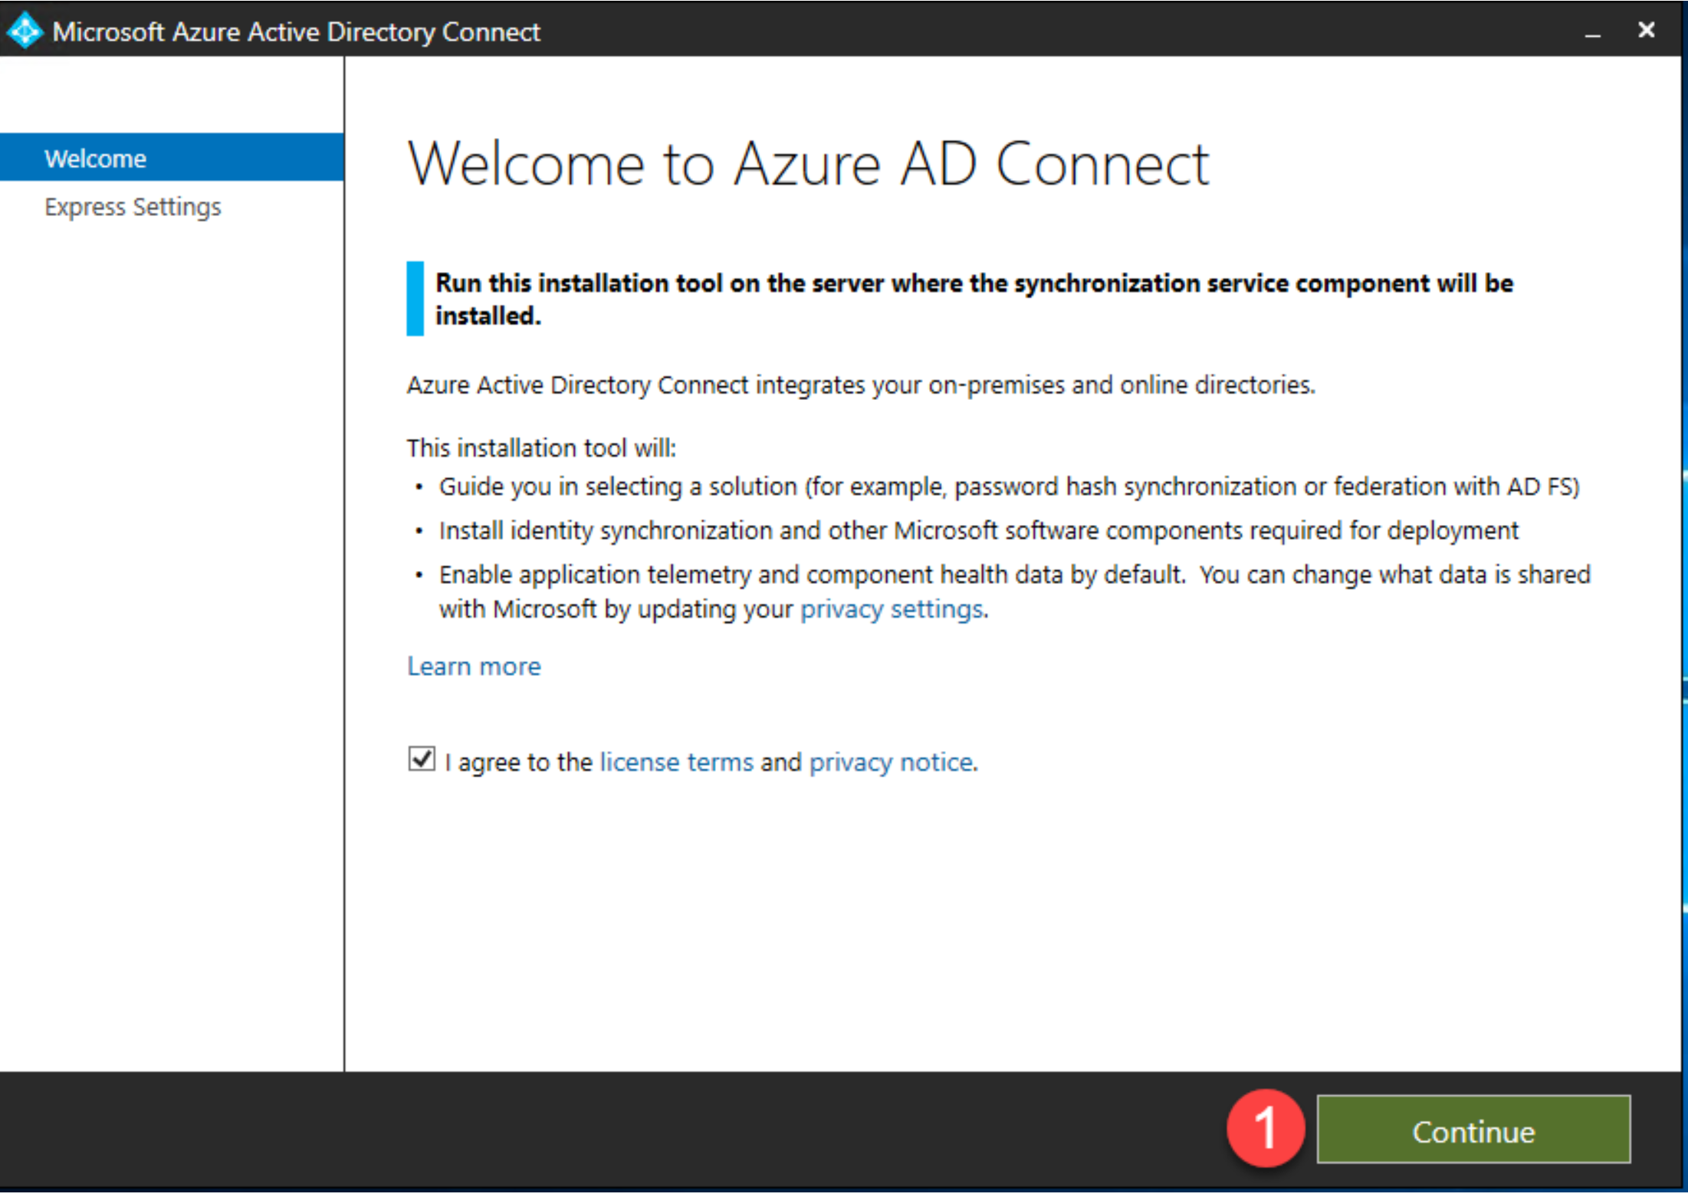

* Once you have chosen the server begin installation. You will choose between [Express and Custom installation](https://docs.microsoft.com/en-us/azure/active-directory/hybrid/how-to-connect-install-select-installation). This post will cover using Express settings.
* Notice message below indicating that the domain is not routable. This will be covered later in the post.
* Click **Use express settings**.

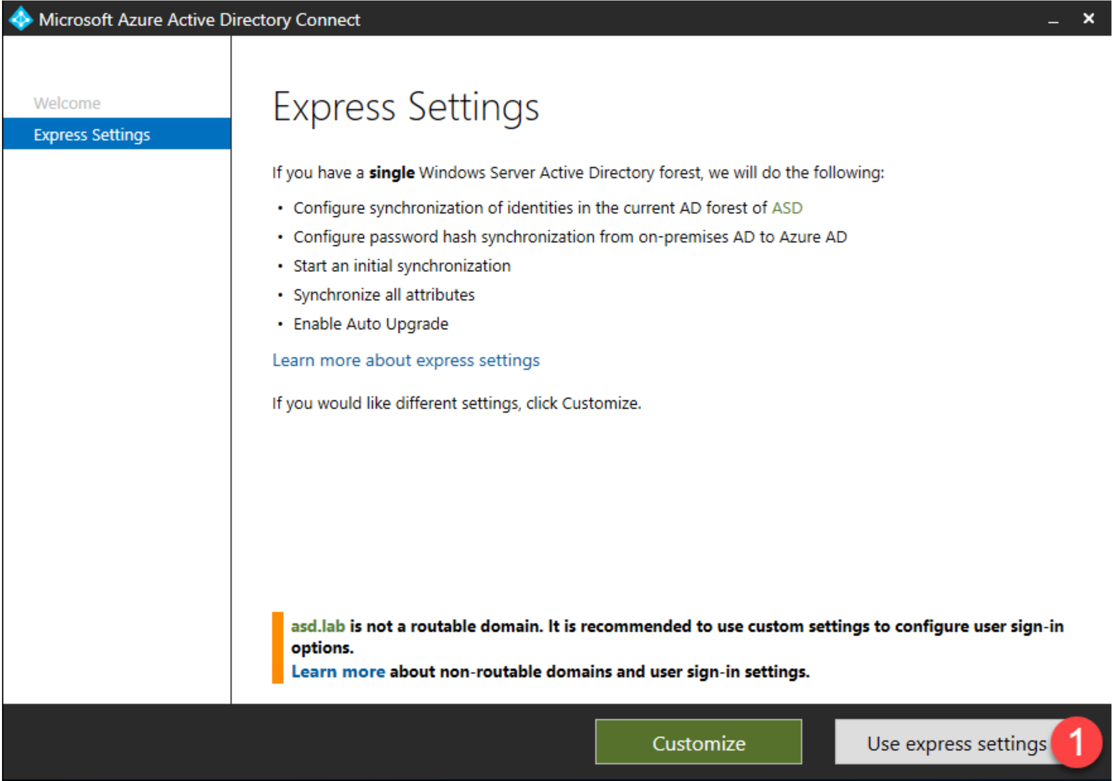

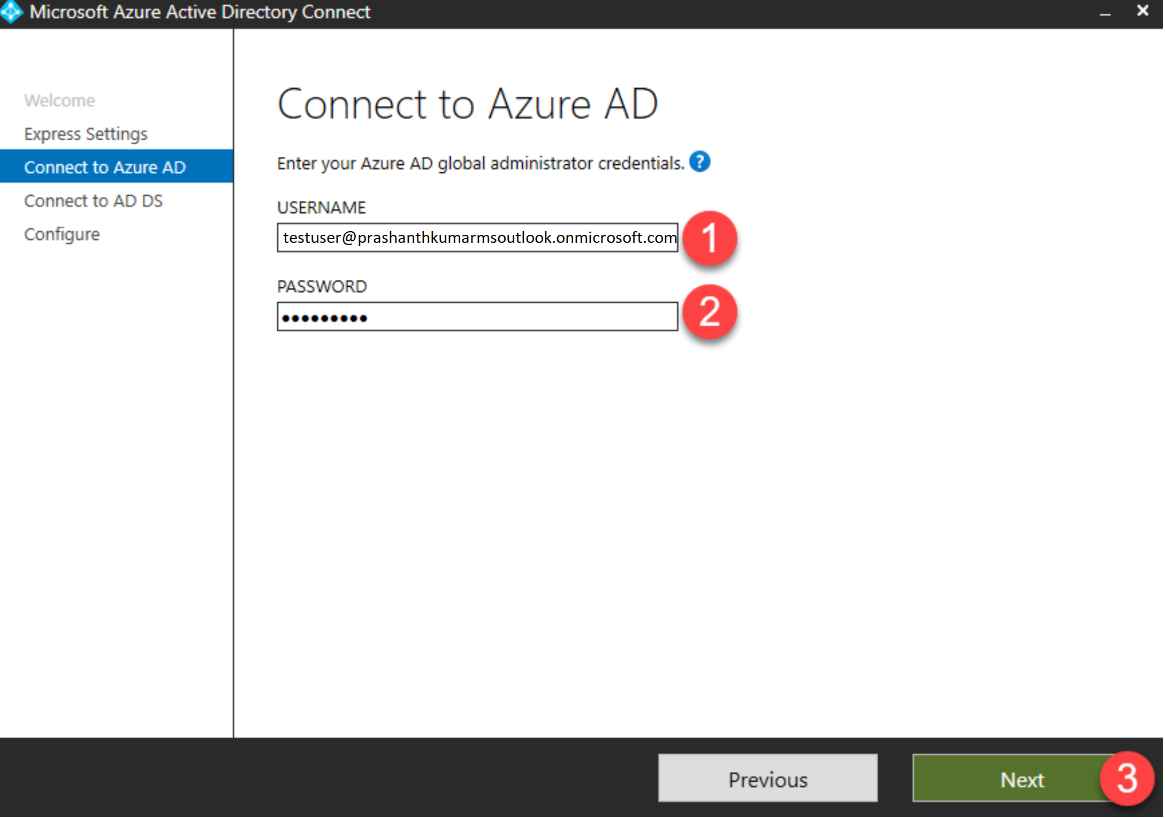

Enter the Active Directory Domain Services enterprise administrator credentials and click **Next** – this account is only needed for configuring AAD Connect.

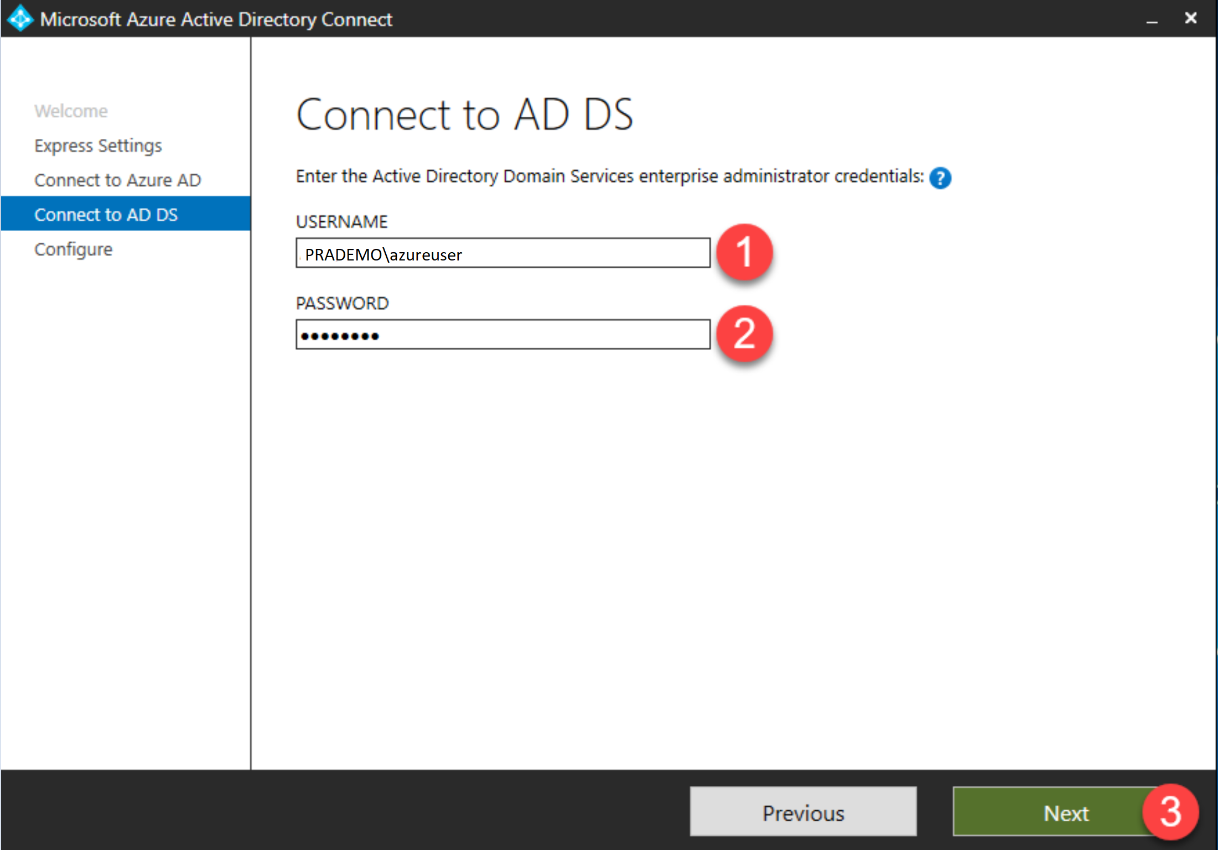

* If you see the Azure AD Sign-in configuration page, review any domains not listed as Verified and verify it in Azure AD before continuing.
* Once you’ve verified your domain, click the Refresh icon and the status should change to Verified.
* Alternatively, you can check the box for **Continue without matching all UPN sufixes to verified domains.** This will allow you to continue the Azure AD Connect wizard, however you will need to complete the verification process before users can log into Azure AD.
* Click **Next**

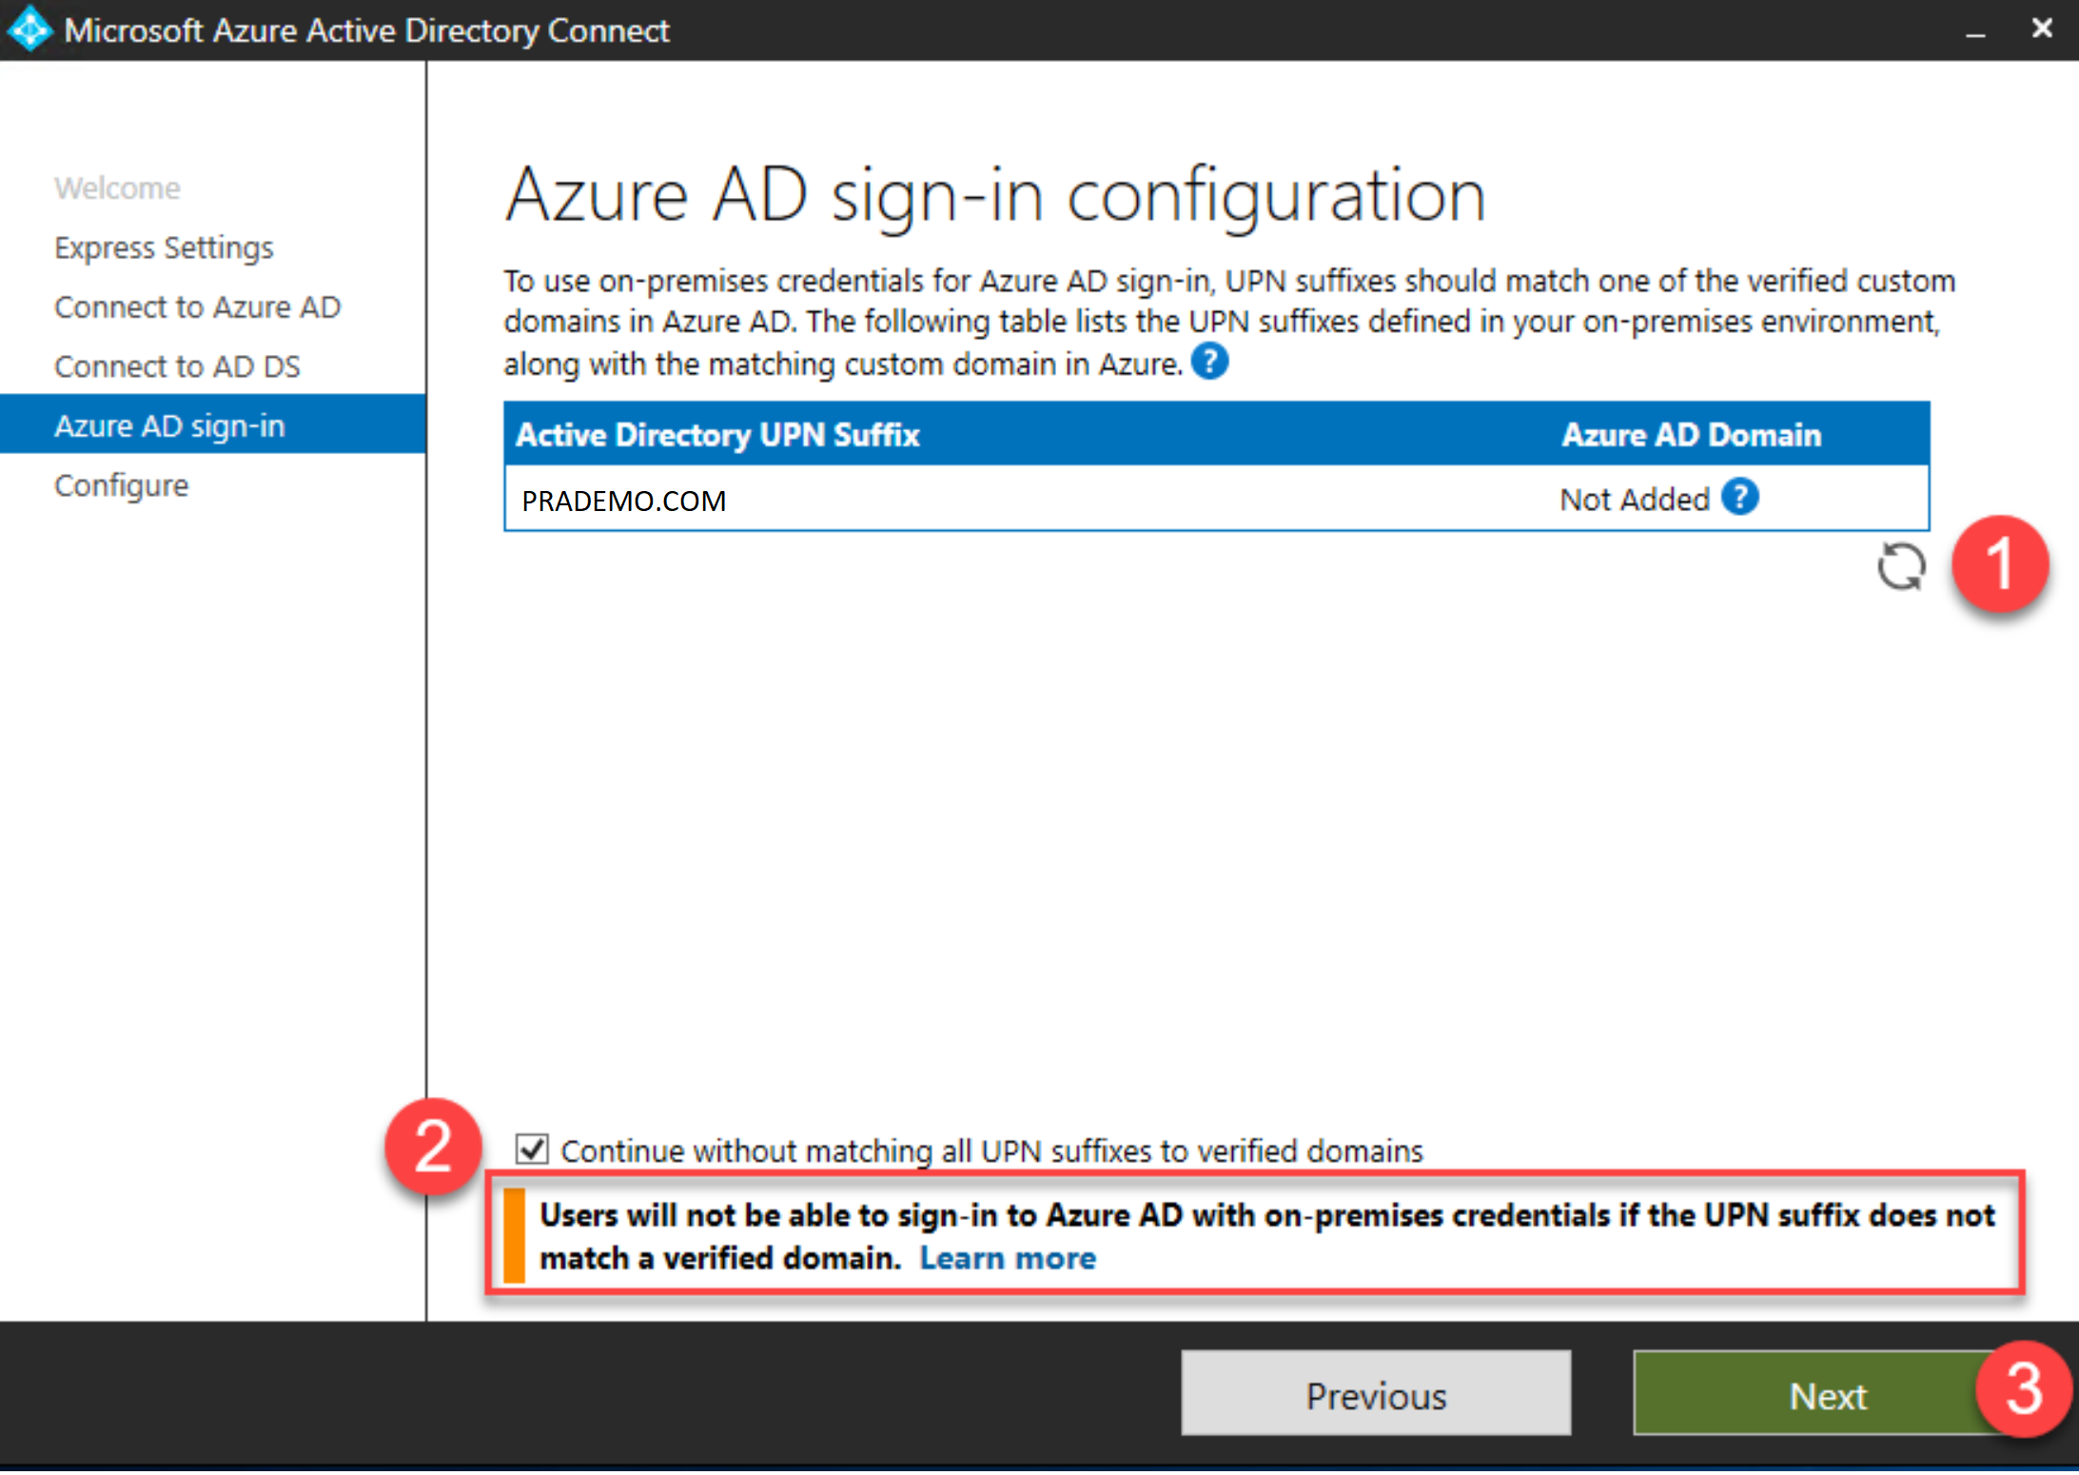

* If you verified your domain(s) in the previous step, check the box for Start the synchronization process when configuration completes, otherwise uncheck the box and click **Install**.
* If you unchecked the box, sync will be configured, but won’t run until you re-run the AAD Connect wizard.

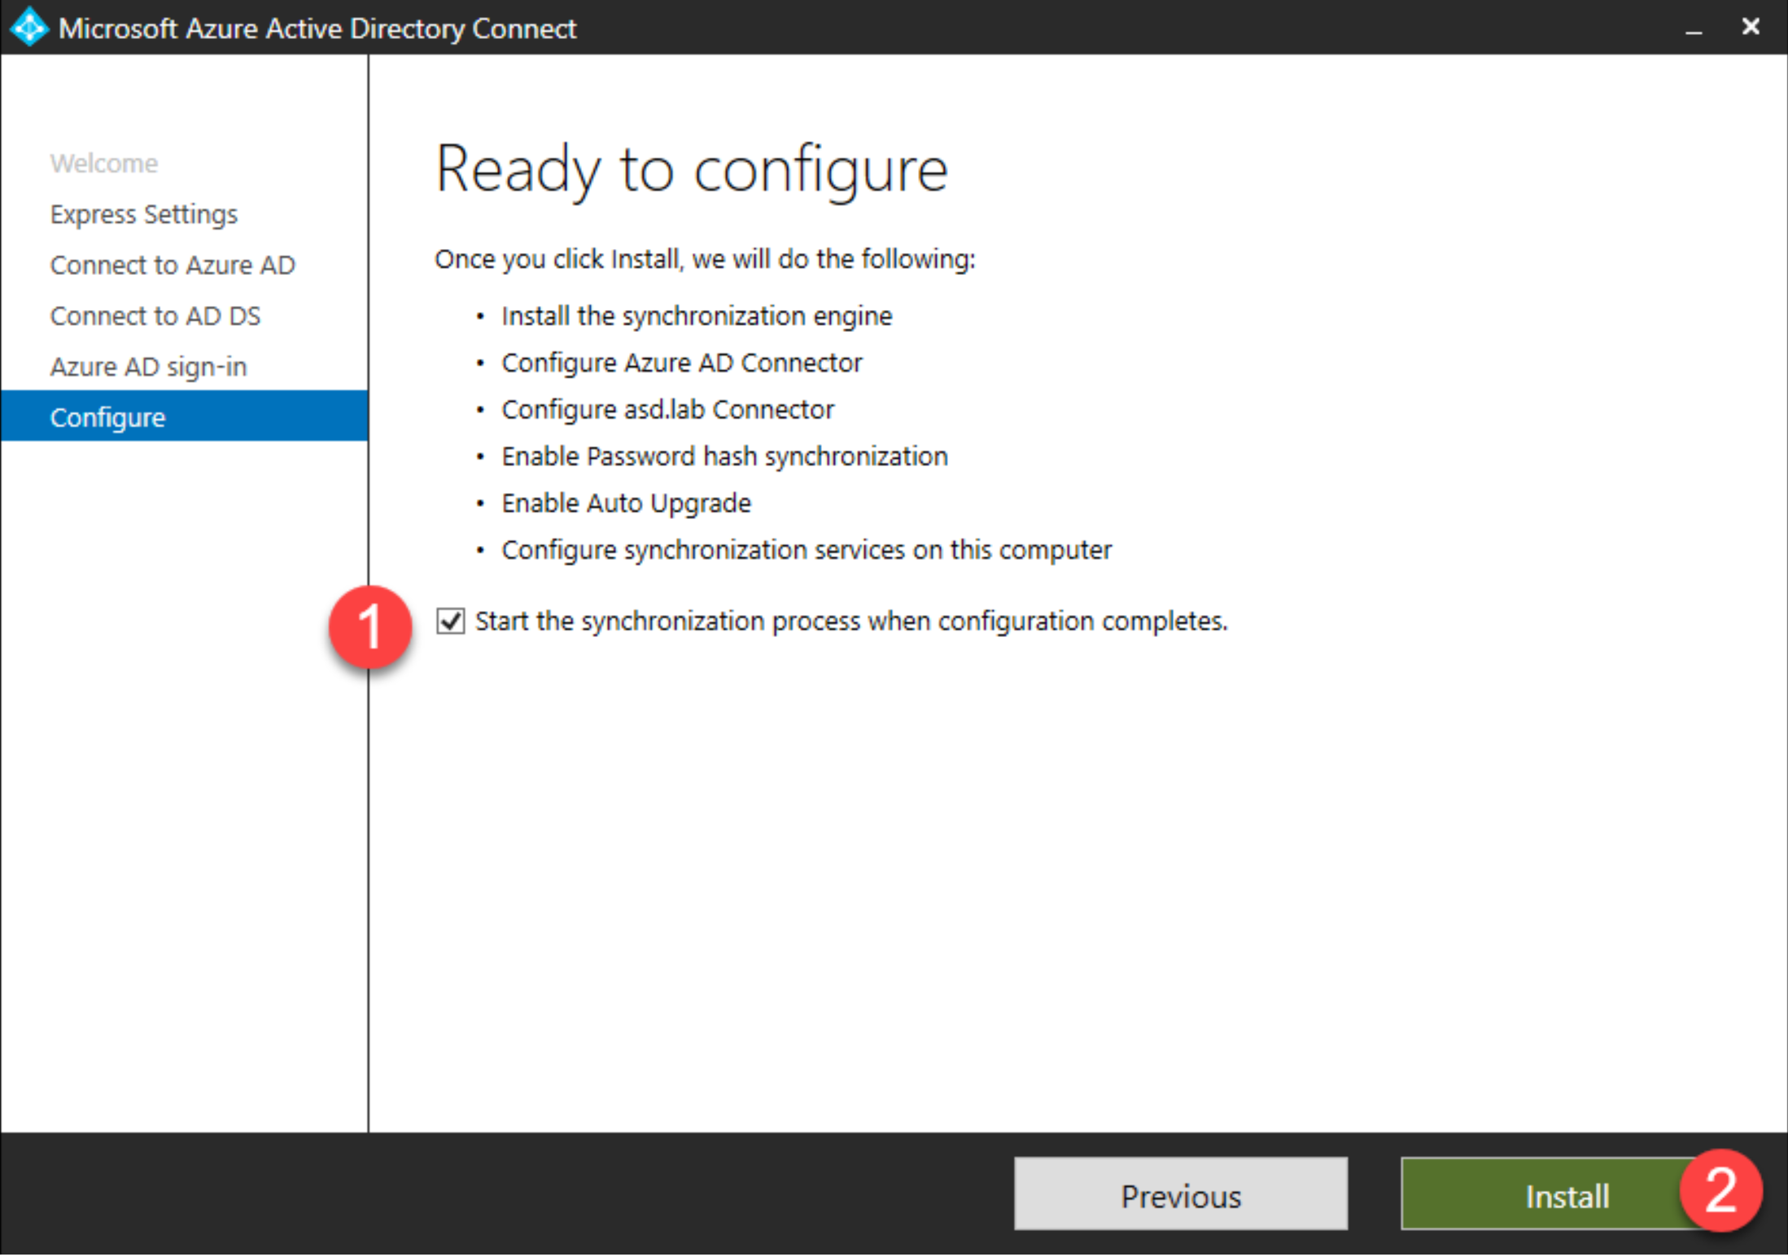

Any errors or action items will be listed in the Configuration complete page. Click Exit to complete setup.

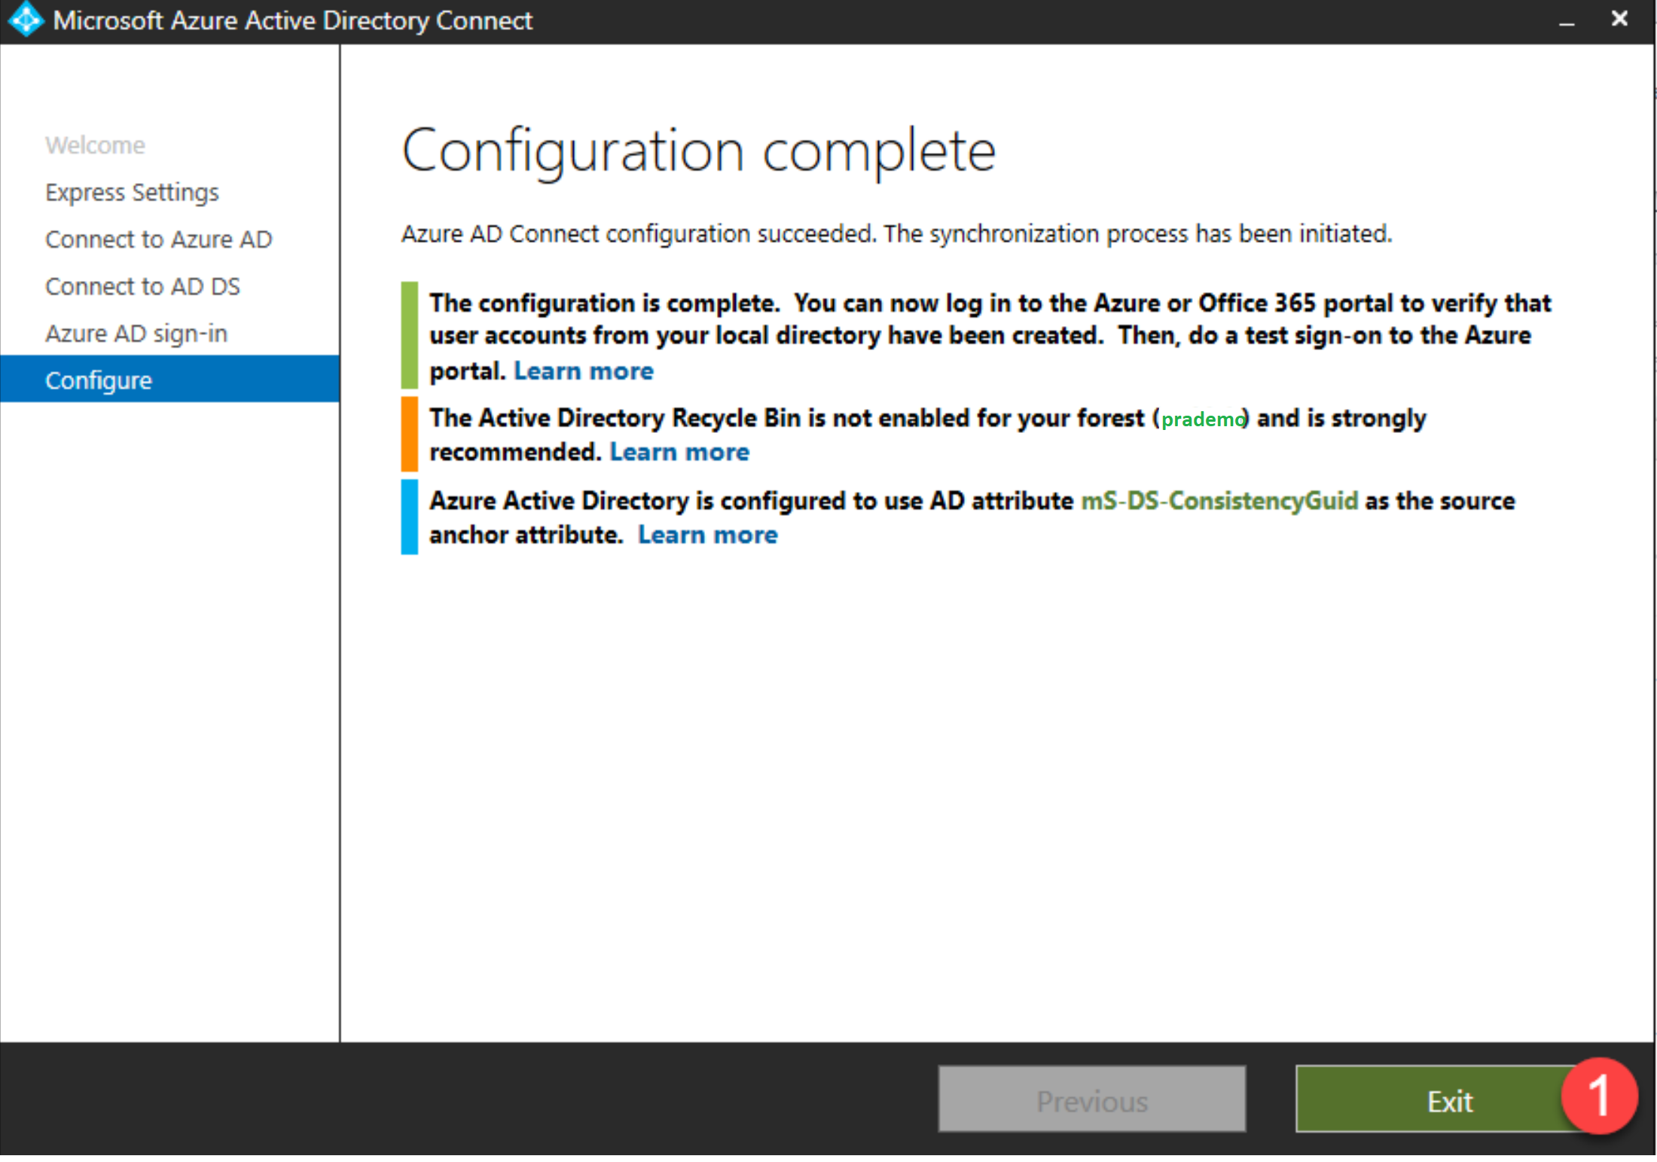

* When you log into your Azure AD tenant and select Users, you should see new synchronized user accounts indicating that sync is working as expected.
* You can also begin assigning licenses to users in Azure at this time.

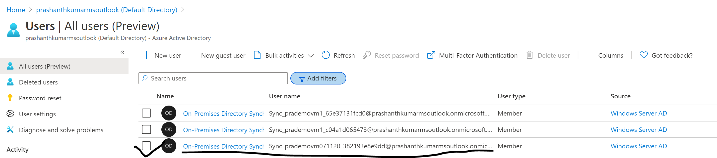

Also if you have any users being created on your Onpremise AD, you can see the same users getting Migrated to Azure as well.



For any activity Sync from OnPremise to Azure AD.

1. Double click on Azure AD Connect

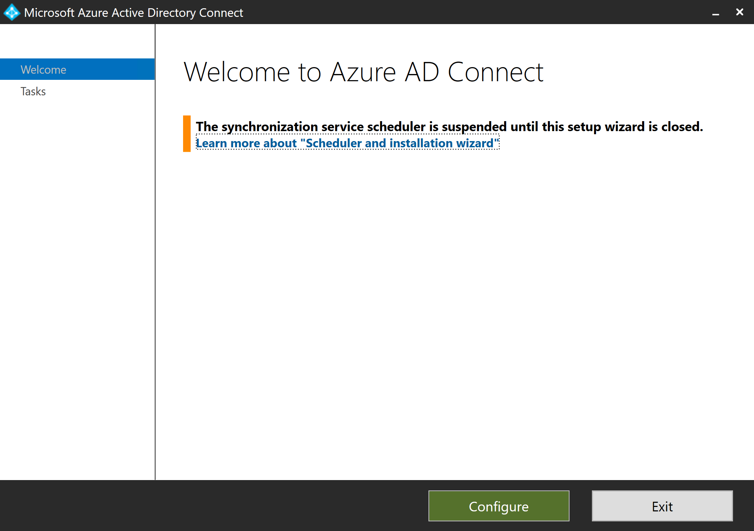

2. It’s going to show all additional tasks.

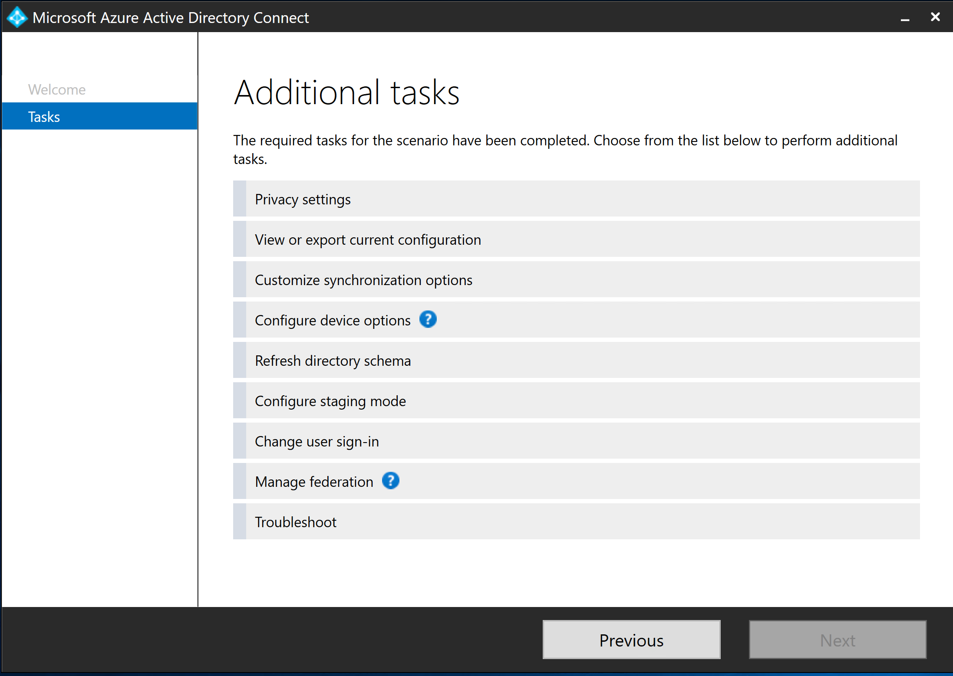

3. Let’s assume I want to remove few users from Onpremise & replicate the same on Azure Cloud 🡪 click on “Customize Synchronization Options”

4. Enter Azure “global admin” user credentials.

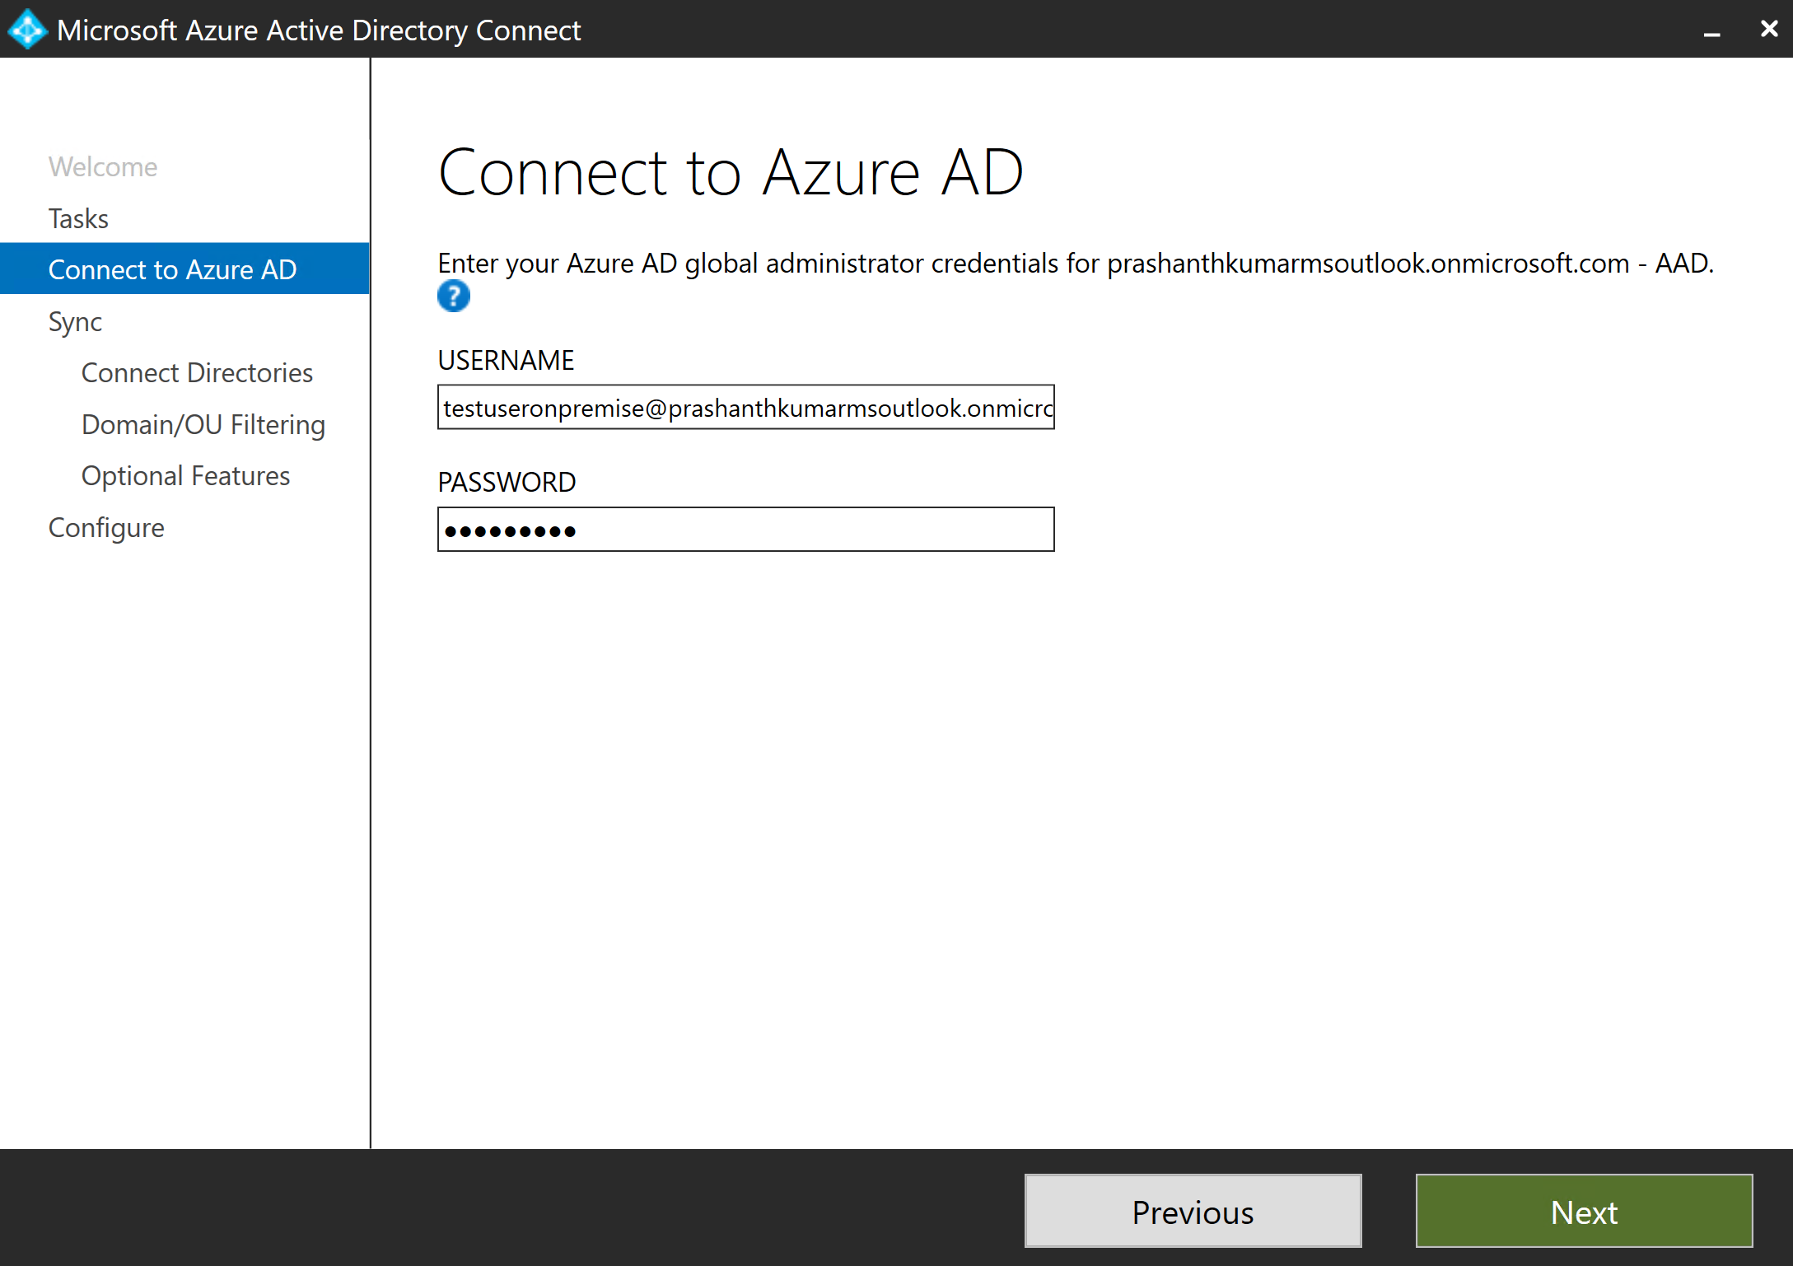

5. Its going to ask for Sync options. 🡪 click Next

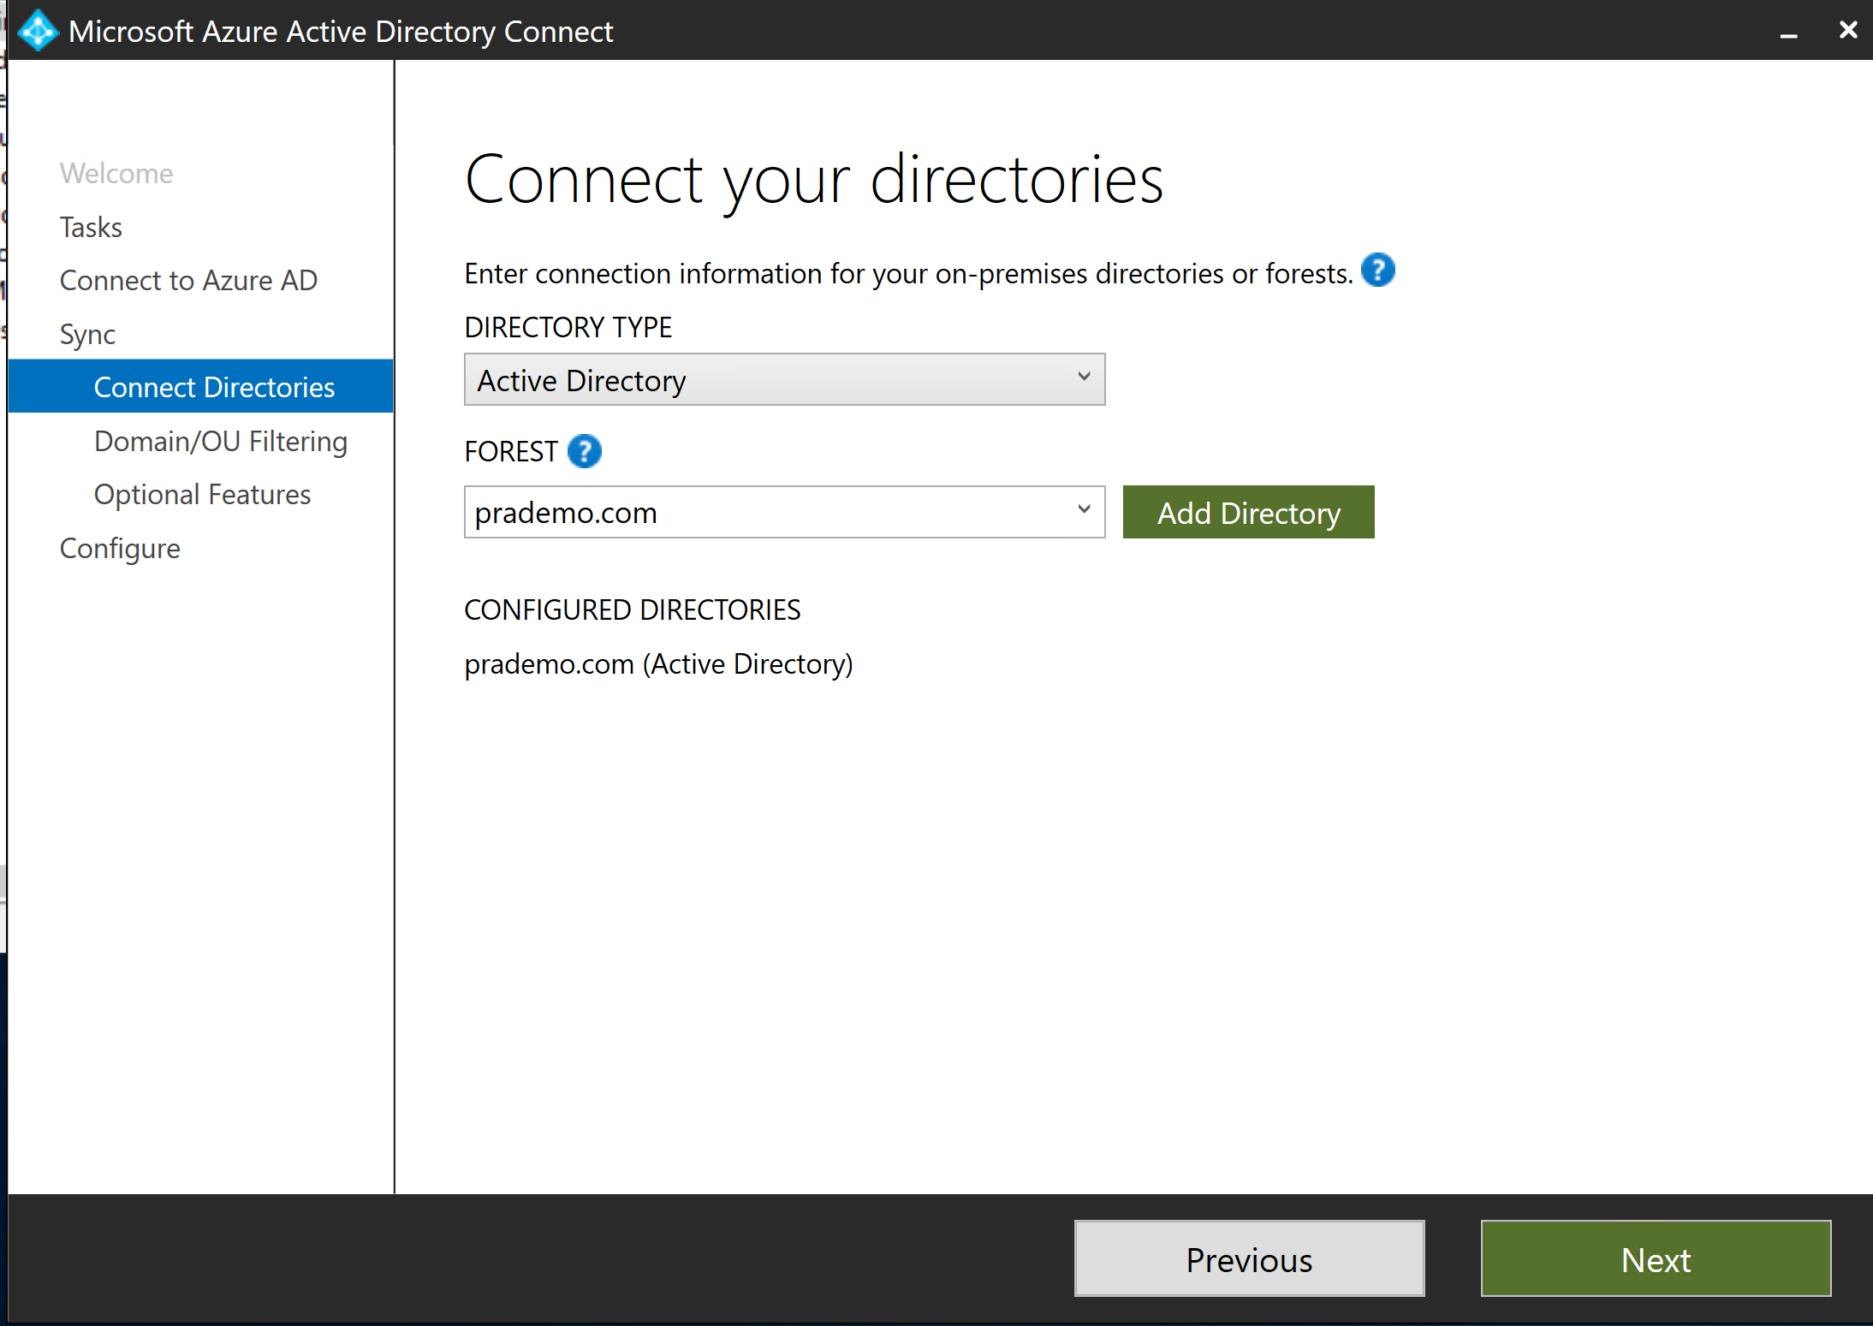

6. Now Open Active Directory Users and computers. 🡪 click on Users.

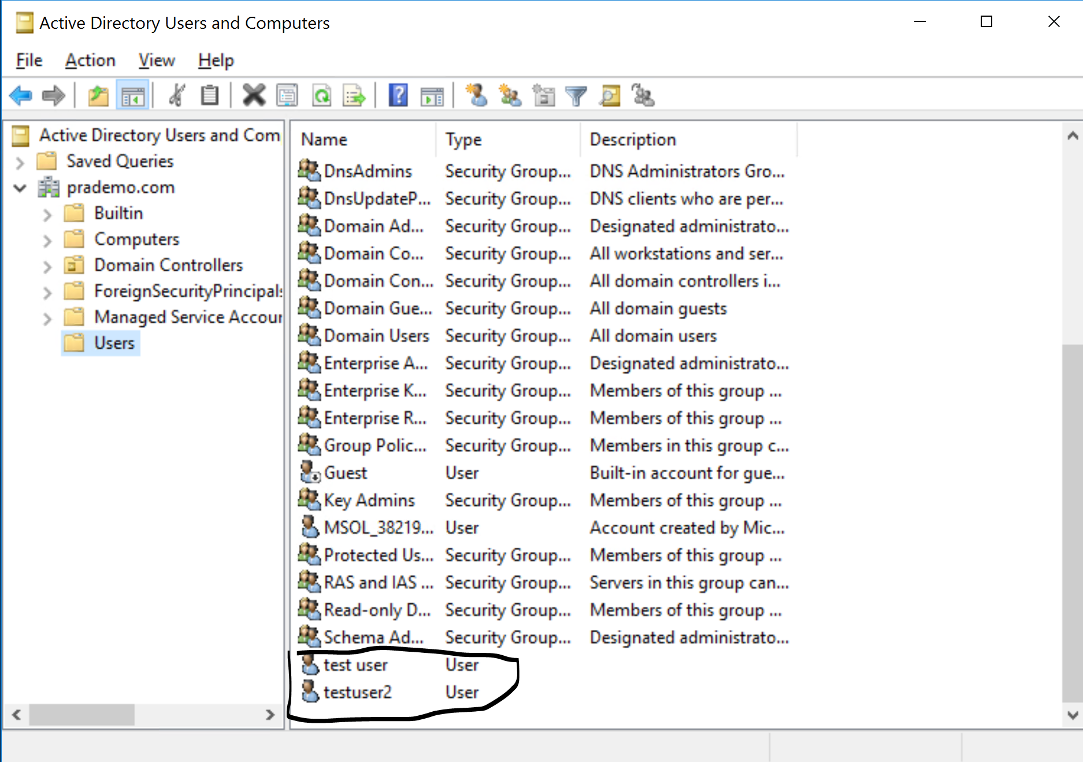

Right click on users 🡪 hit Delete.

Now lets go back to AD Sync window 🡪 Select the option “Sync Selected Domains and OU’s” 🡪 select only “Users” 🡪 Click Next.

7. Select the option “Password Hash Synchronization” and “Password write back”.

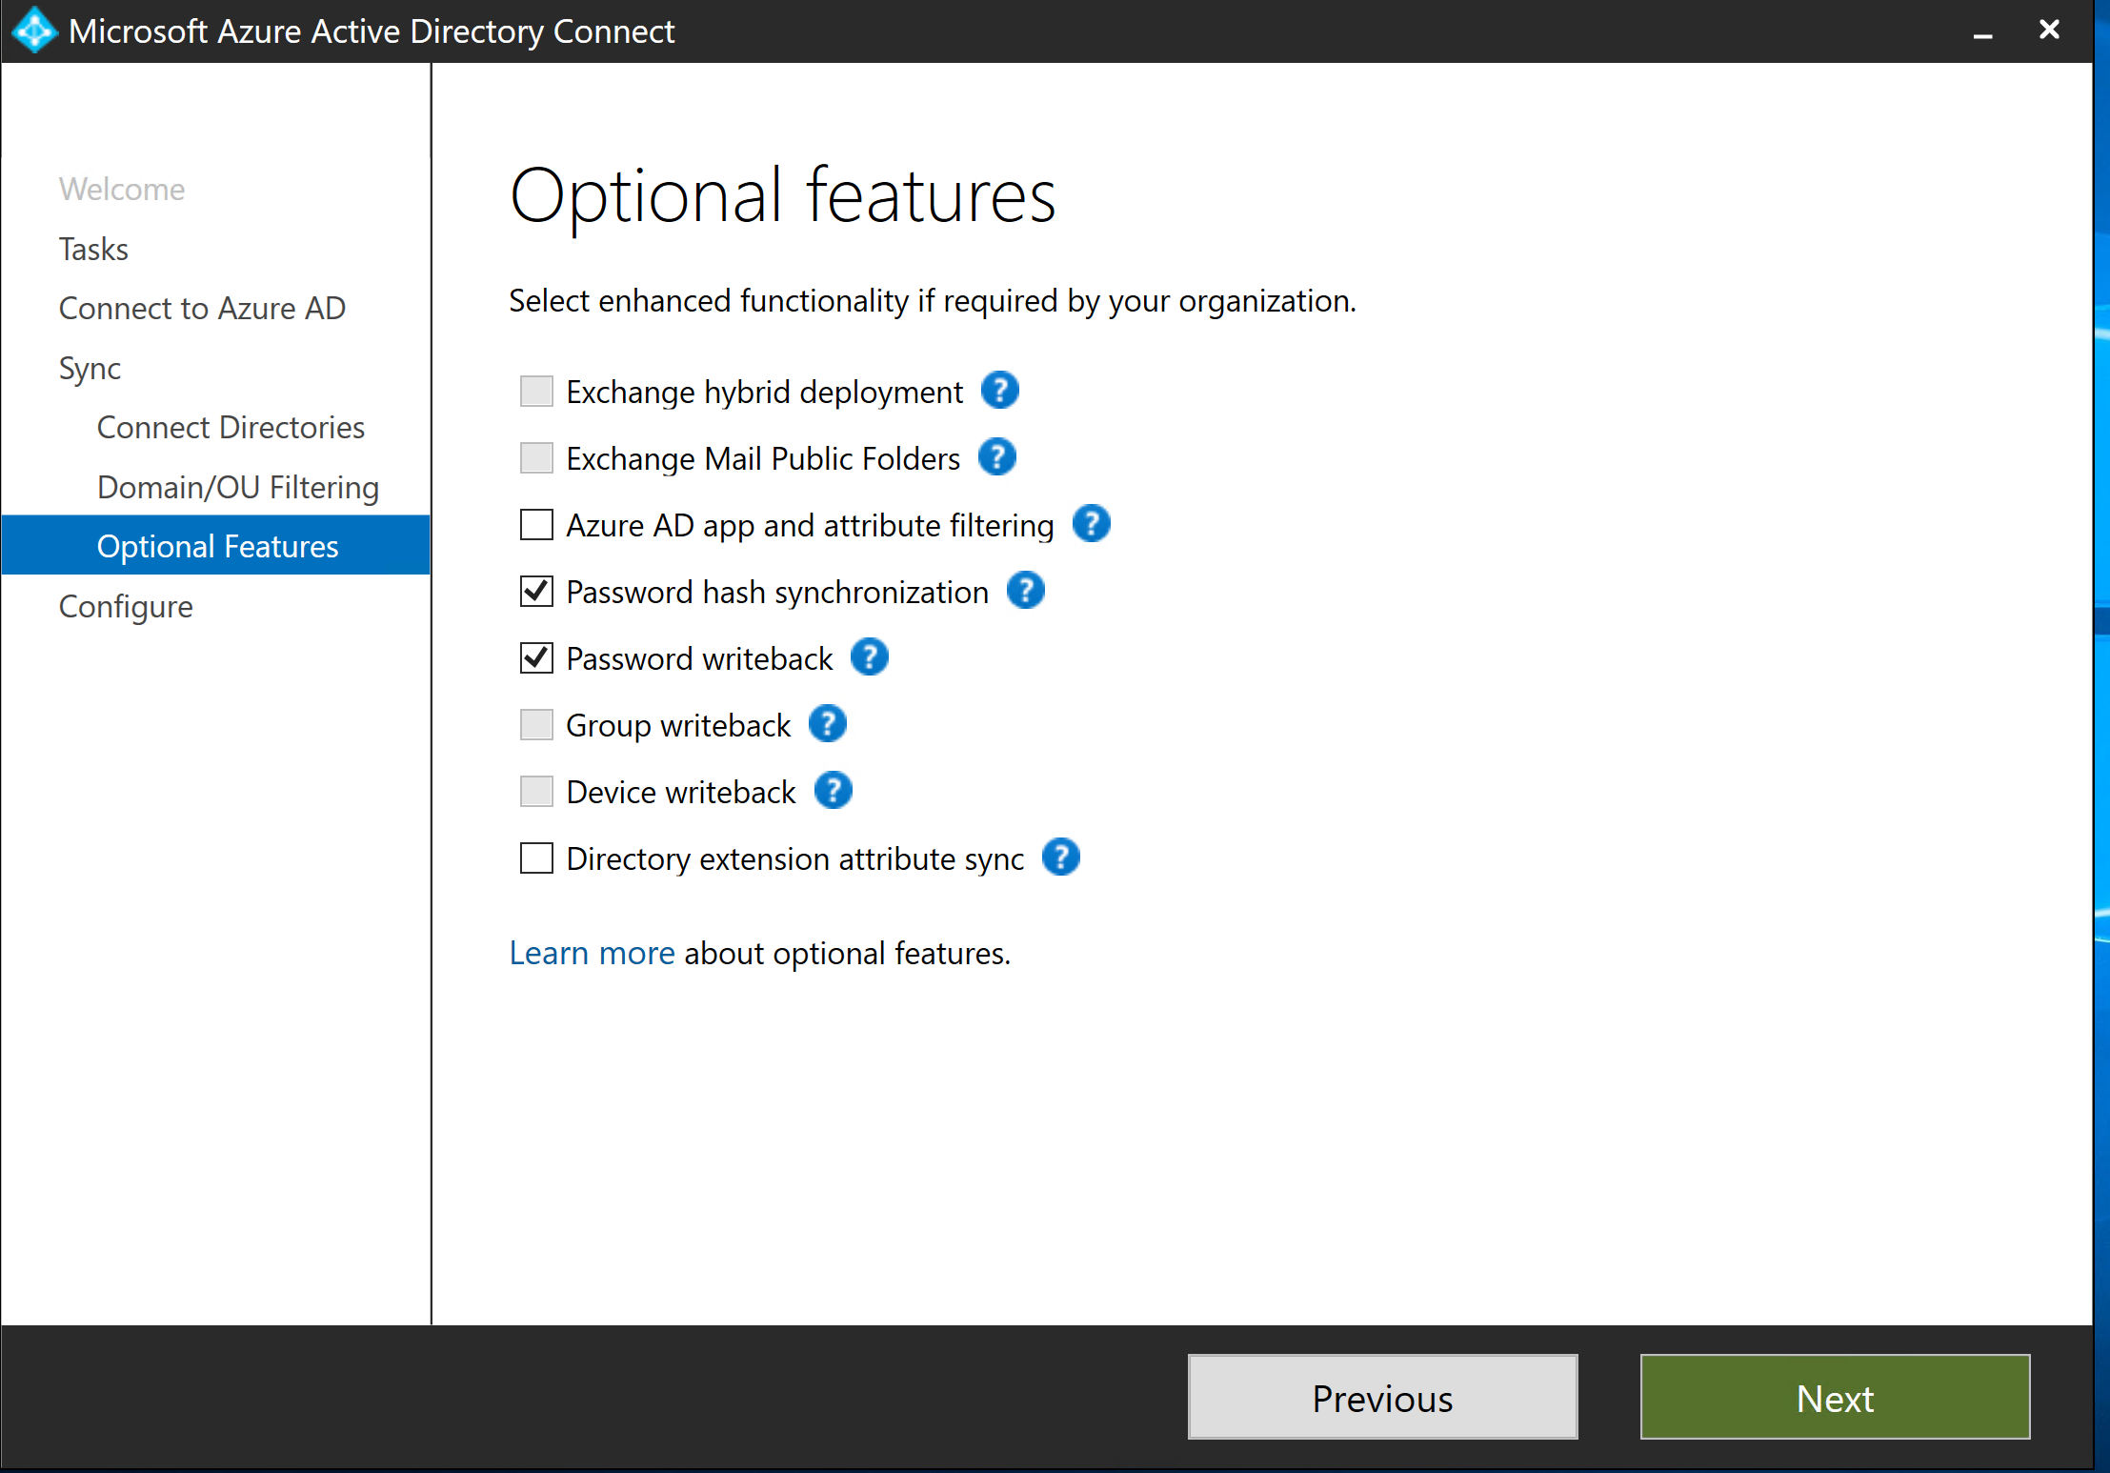

8. Finally its going to configure.

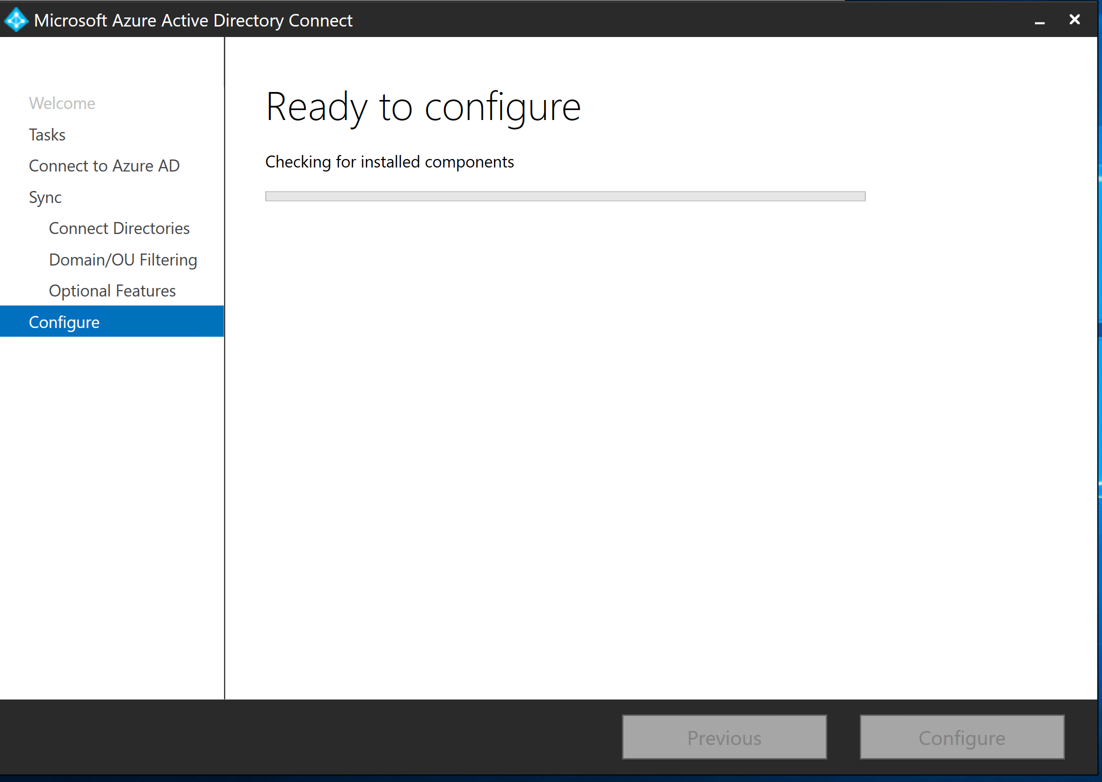

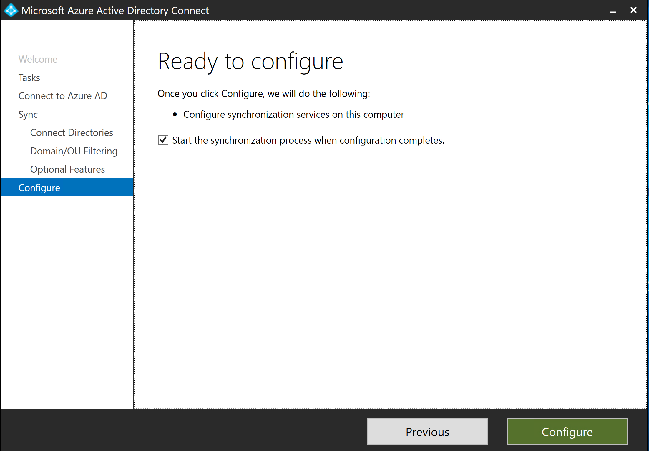

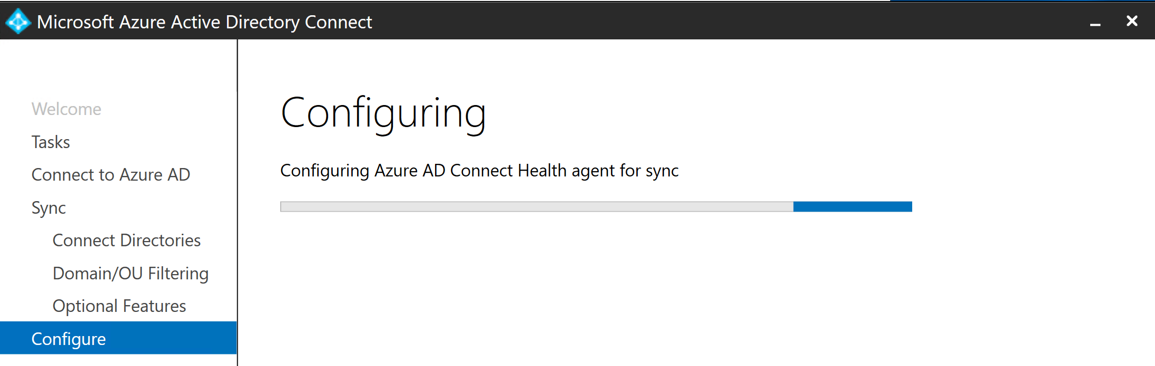

9. finally I am going to validate the users in Azure AD.

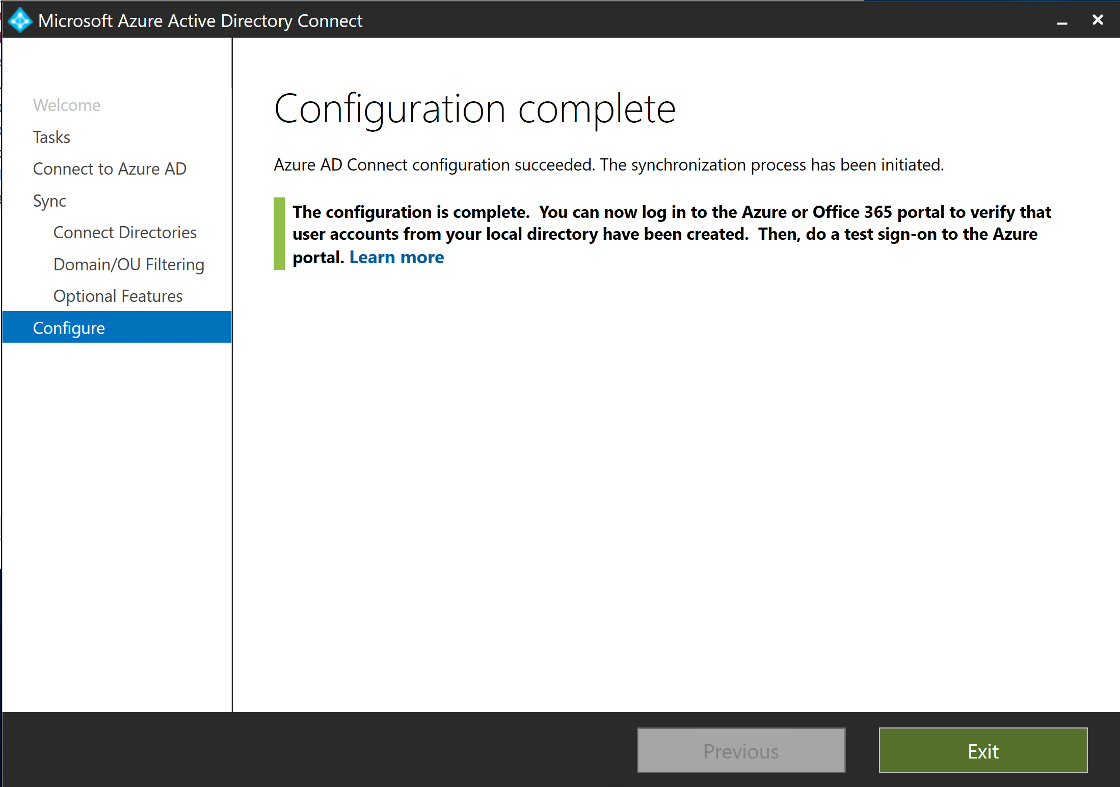

Now you can login to <https://portal.azure.com> 🡪 open Azure Active directory 🡪 users and Old users from Onpremise environment no longer exist.

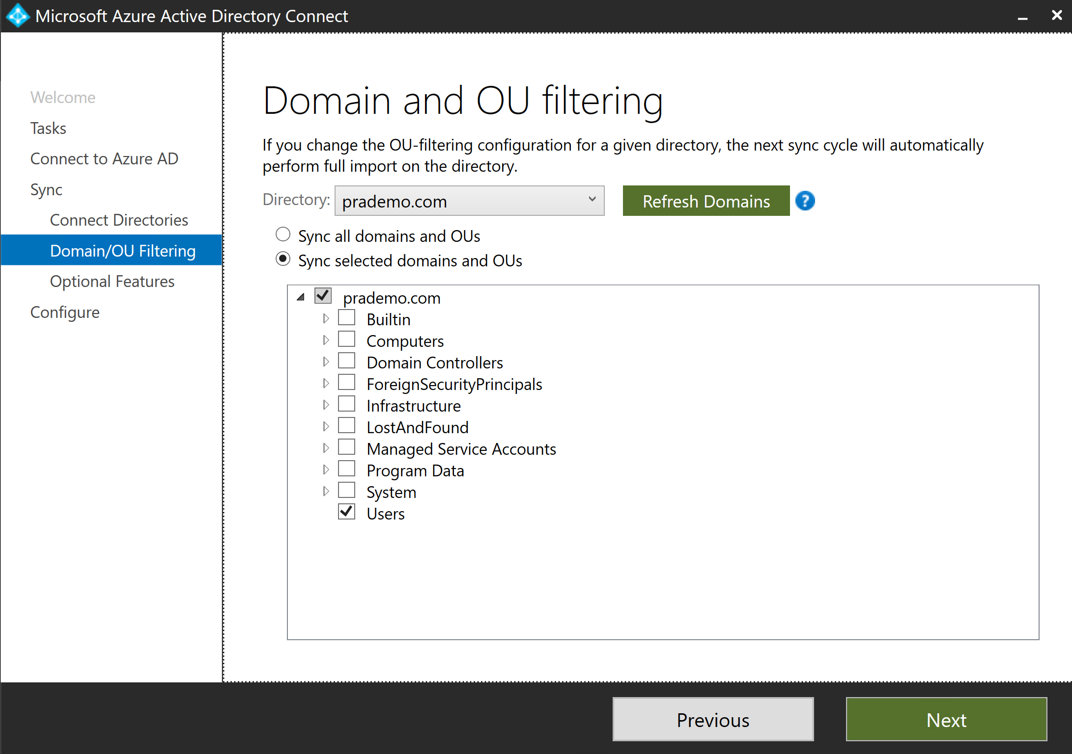

**Questions:**

Question 1 You host a service with two Azure virtual machines. You discover that occasional outages cause your service to fail. What two actions can you do to minimize the impact of the outages?

† Add a load balancer.

† Put the virtual machines in an availability set.

† Put the virtual machines in a scale set.

† Add a network gateway.

† Add a third instance of the virtual machine.

Question 2 You are researching Microsoft Azure for your company. The company is considering deploying Windows-based VMs in Azure. However, before moving forward, the management team has asked you to research the costs associated with Azure VMs. You need to document the configuration options that are likely to save the company money on their Azure VMs. Which options should you document? (Each answer presents part of the solution. Choose four.)

† Use HDD instead of SSD for VM storage.

† Use unmanaged premium storage instead of managed standard storage.

† Bring your own Windows custom images.

† Use different Azure regions.

† Use the least powerful VMs that meet your requirements.

† Place all VMs in the same resource group.

† Bring your own Windows license for each VM.

Question 3 You are planning to deploy several Linux VMs in Azure. The security team issues a policy that Linux VMs must use an authentication system other than passwords. You need to deploy an authentication method for the Linux VMs to meet the requirement. Which authentication method should you use? Select one.

† SSH key pair

† Azure multi-factor authentication

† Access keys

† Shared access signature

† Security vault certificate

Question 4 You deploy a new VM with default settings to a resource group named RG1. You validate that you can connect to it by using Remote Desktop Connection. However, when you attempt to connect to it through PowerShell remoting, the connection fails. You need to ensure that you can manage the VM by using PowerShell remoting. What should you do? Select one.

† Create an inbound security rule to allow TCP port 80 and TCP port 443.

† Create an inbound security rule to allow TCP port 5985 and TCP port 5986.

† Create an inbound security rule to allow TCP port 3389.

† Create an inbound security rule to allow TCP port 20 and TCP port 21.

Question 5 Your company has Windows Server 2012 R2 VMs and Ubuntu Linux VMs in Microsoft Azure. The company has a new project to standardize the configuration of servers across the Azure environment. The company opts to use Desired State Configuration (DSC) across all VMs. You need to ensure that DSC can be used across all the VMs. What two things should you do?

† Replace the Ubuntu VMs with Red Hat Enterprise Linux VMs.

† Deploy the DSC extension for Windows Server VMs.

† Deploy the DSC extension for Linux VMs.

† Replace the Windows Server 2012 R2 VMs with Windows Server 2016 VMs.

Question 6 Another IT administrator creates an Azure virtual machine scale set with 5 VMs. Later, you notice that the VMs are all running at max capacity with the CPU being fully consumed. However, additional VMs are not deploying in the scale set. You need to ensure that additional VMs are deployed when the CPU is 75% consumed. What should you do? Select one.

† Enable the autoscale option.

† Increase the instance count.

† Add the scale set automation script to the library.

† Deploy the scale set automation script.

Question 7 Your company is preparing to deploy an application to Microsoft Azure. The app is a self-contained unit that runs independently on several servers. The company is moving the app to the cloud to provide better performance. To get better performance, the team has the following requirements:

● If the CPU across the servers goes above 85%, a new VM should be deployed to provide additional resources.

● If the CPU across the servers drops below 15%, an Azure VM running the app should be decommissioned to reduce costs.

You need to deploy a solution to meet the requirements while minimizing the administrative overhead to implement and manage the solution. What should you do? Select one.

† Deploy the app in a virtual machine scale set.

† Deploy the app in a virtual machine availability set.

† Deploy the app by using a resource manager template.

† Deploy the app and use PowerShell Desired State Configuration (DSC).

Question 8 Your company is deploying a critical business application to Microsoft Azure. The uptime of the application is of utmost importance. The application has the following components:

● 2 web servers

● 2 application servers

● 2 database servers

You need to design the layout of the VMs to meet the following requirements:

● Each VM in a tier must run on different hardware

● Uptime for the application must be maximized

You need to deploy the VMs to meet the requirements. What should you do? Select one.

† Deploy 1 VM from each tier into one availability set and the remaining VMs into a separate availability set.

† Deploy the VMs from each tier into a dedicated availability set for the tier.

† Deploy the application and database VMs in one availability set and the web VMs into a separate availability set.

† Deploy a load balancer for the web VMs and an availability set to hold the application and database VMs.

Question 9 You deploy an Azure VM into an availability set. The VM is the only VM in the availability set. The VM runs an application named App1. The VM has the following characteristics:

● The VM uses Azure standard storage.

● The VM does not have any data disks.

● The VM was built with a custom image.

During an Azure planned maintenance event, the VM experiences downtime. The company issues a new requirement for App1: ● App1 must remain available during Azure planned maintenance events

You need to reconfigure your environment to meet the new requirements. What should you do? (Each answer presents a complete solution. Choose two.)

† Deploy a second Azure VM and add it to the same availability set.

† Deploy a second Azure VM and add it to the same update domain.

† Deploy a second Azure VM and add it to the same fault domain.

† Convert the VM storage to premium storage.

† Convert the VM to a Standard size or higher.

† Convert the VM storage to use zone redundant storage.

Question 10 You begin a new job at a company. You are exploring the existing Microsoft Azure implementation with a plan to document it. First, you are documenting the virtual machine details. You need to go gather the details of the VM data disks. Which type of storage should you review for the data disks? Select one.

† Azure CDN

† Blob storage

† Table storage

† Queue storage

**Links:**

PowerShell DSC

<https://docs.microsoft.com/en-us/powershell/dsc/overview/overview>

if you guys wants to understand the template and its flow, I would recommend to check below link.

<https://github.com/PowerShell/DscResource.Tests>

Best Practices for Autoscale –

<https://docs.microsoft.com/en-us/azure/monitoring-and-diagnostics/insights-autoscale-best-practices>

Virtual machine extensions and features for Windows –

<https://docs.microsoft.com/en-us/azure/virtual-machines/extensions/features-windows?toc=%2Fazure%2Fvirtual-machines%2Fwindows%2Ftoc.json>

Virtual machine extensions and features for Linux –

<https://docs.microsoft.com/en-us/azure/virtual-machines/extensions/features-linux>

Built-In Windows PowerShell Desired State Configuration Resources –

<https://docs.microsoft.com/en-us/powershell/dsc/resources/resources#built-in-resources>

Linux virtual machines (Documentation) –

<https://docs.microsoft.com/en-us/azure/virtual-machines/linux/>

Azure Pricing Calculator

<https://azure.microsoft.com/en-in/pricing/calculator/>

<https://azprice.info/>

GET [https://management.azure.com/{scope}/providers/Microsoft.Consumption/usageDetails?api-version=2019-01-01](https://management.azure.com/%7bscope%7d/providers/Microsoft.Consumption/usageDetails?api-version=2019-01-01)

SSH key (how public and private key works)

<https://www.ssh.com/ssh/public-key-authentication>

Storage

the default endpoints for your storage account are:

● Blob service: <http://mystorageaccount.blob.core.windows.net>

● Table service: <http://mystorageaccount.table.core.windows.net>

● Queue service: <http://mystorageaccount.queue.core.windows.net>

● File service: <http://mystorageaccount.file.core.windows.net>

**Create a storage account using PowerShell**

Use the following code to create a storage account using PowerShell. Swap out the storage types and names to suit your requirements.

Get-AzLocation | select Location

$location = "westus"

$resourceGroup = "storage-demo-resource-group"

New-AzResourceGroup -Name $resourceGroup -Location $location

New-AzStorageAccount -ResourceGroupName $resourceGroup -Name "storagedemo" -Location $location -SkuName Standard_LRS -Kind StorageV2

**Create a storage account using Azure CLI**

Use the following code to create a storage account using Azure CLI. Change the storage types and names to suit your requirements.

az group create --name storage-resource-group --location westus

az account list-locations --query "[].{Region:name}" --out table

az storage account create --name storagedemo --resource-group storage-resource-group --location westus --sku Standard_LRS --kind StorageV2

Download and install Azure Storage Explorer –

<https://azure.microsoft.com/en-us/features/storage-explorer>

What is Azure Files?-

<https://docs.microsoft.com/en-us/azure/storage/files/storage-files-introduction>

Creating a file share (PowerShell) You can also use PowerShell to create a file share.

# Retrieve storage account and storage account key

$storageContext = New-AzStorageContext <storage-account-name> <storage-account-key>

# Create the file share, in this case “logs”

$share = New-AzStorageShare logs -Context $storageContext

Secure file transfer:

how to use PowerShell and the EnableHttpsTrafficOnly parameter.

Set-AzStorageAccount -Name <StorageAccountName> -ResourceGroupName <ResourceGroupName> -EnableHttpsTrafficOnly $True

Demonstration - File Shares In this demonstration, we will work with files shares and snapshots.

Note: These steps require a storage account.

Create a file share and upload a file

1. Access your storage account, and click Files.

2. Click + File share and give your new file share a Name and a Quota.

3. After your file share is created Upload a file.

4. Notice the ability to Add a directory, Delete share, and edit the Quota.

Manage snapshots

1. Access your file share.

2. Select Create Snapshot.

3. Select View Snapshots and verify your snapshot was created.

4. Click the snapshot and verify it includes your uploaded file.

5. Click the file that is part of the snapshot and review the File properties.

6. Notice the choices to Download and Restore the snapshot file.

7. Access the file share and delete the file you previously uploaded.

8. Restore the file from the snapshot.

Create a file share (PowerShell)

1. Create a context for your storage account and key The context encapsulates the storage account name and account key.

$storageContext = New-AzStorageContext storage-account-name storage-account-key

1. Create the file share. The name of your file share must be all lowercase.

$share = New-AzStorageShare logs -Context $storageContext

Mount a file share (PowerShell)

Note: Run the following commands from a regular (i.e. not an elevated) PowerShell session to mount the Azure file share. Remember to replace <your-resource-group-name>, <your-storage-account-name>, <your-file-share-name>, and desired-drive-letter with the proper information.

$resourceGroupName = "your-resource-group-name"

$storageAccountName = "your-storage-account-name"

$fileShareName = "your-file-share-name"

# These commands require you to be logged into your Azure account, run Login-AzAccount if you haven't # already logged in.

$storageAccount = Get-AzStorageAccount -ResourceGroupName $resourceGroupName -Name $storageAccountName $storageAccountKeys = Get-AzStorageAccountKey -ResourceGroupName $resourceGroupName -Name $storageAccountName $fileShare = Get-AzStorageShare -Context $storageAccount.Context | Where-Object { $_.Name -eq $fileShareName -and $_.IsSnapshot -eq $false }

if ($fileShare -eq $null) { throw [System.Exception]::new("Azure file share not found") }

# The value given to the root parameter of the New-PSDrive cmdlet is the host address for the storage account, # storage-account.file.core.windows.net for Azure Public Regions.

$fileShare. StorageUri.PrimaryUri.Host is # used because non-Public Azure regions, such as sovereign clouds or Azure Stack deployments, will have different

# hosts for Azure file shares (and other storage resources).

$password = ConvertTo-SecureString -String $storageAccountKeys[0].Value -AsPlainText -Force $credential = New-Object System.Management.Automation.PSCredential -ArgumentList "AZURE\$($storageAccount.StorageAccountName)", $password New-PSDrive -Name desired-drive-letter -PSProvider FileSystem -Root

"\\$($fileShare.StorageUri.PrimaryUri.Host)\$($fileShare.Name)" -Credential $credential -Persist

When finished, you can dismount the file share by running the following command:

Remove-PSDrive -Name desired-drive-letter MCT

What is a shared access signature? –

<https://docs.microsoft.com/en-us/azure/storage/common/storage-dotnet-shared-access-signature-part-1?toc=%2fazure%2fstorage%2fblobs%2ftoc.Json#what-is-a-shared-access-signature>

Configuring SAS Parameters

PowerShell Options Create a storage account level SAS with full permissions.

New-AzStorageAccountSASToken -Service Blob,File,Table,Queue -ResourceType Service,Container,Object -Permission "racwdlup"

Create a Blob level SAS will full permisions.

New-AzStorageBlobSASToken -Container "ContainerName" -Blob "BlobName" -Permission rwd

Here is an example URI. Each part is described in the table below. https://myaccount.blob.core.windows.net/?restype=service&comp=properties&sv=2015-04-05&ss=bf&srt=s&st=2015-04-29T22%3A18%3A26Z&se=2015-0430T02%3A23%3A26Z&sr=b&sp=rw&sip=168.1.5.60-168.1.5.70&spr=https &sig=F%6GRVAZ5Cdj2Pw4txxxxx

Shared access signature parameters –

<https://docs.microsoft.com/en-us/azure/storage/common/storage-dotnet-shared-access-signature-part-1?toc=%2fazure%2fstorage%2fblobs%2ftoc.json#shared-access-signature-parameters>

Lab and Review Questions

Lab - Implement and Manage Storage Scenario Adatum Corporation wants to leverage Azure Storage for hosting its data

Objectives

After completing this lab, you will be able to:

● Deploy an Azure VM by using an Azure Resource Manager template.

● Implement and use Azure Blob Storage.

● Implement and use Azure File Storage.

Exercise 0: Prepare the lab environment. The main task for this exercise is as follows:

● Deploy an Azure VM by using an Azure Resource Manager template.

Result: After you completed this exercise, you have initiated template deployment of an Azure VM az1000201-vm1 that you will use in the second exercise of this lab.

Exercise 1: Implement and use Azure Blob Storage.

● The main tasks for this exercise are as follows:

● Create Azure Storage accounts.

● Review configuration settings of Azure Storage accounts.

● Manage Azure Storage Blob Service.

● Copy a container and blobs between Azure Storage accounts.

● Use a Shared Access Signature (SAS) key to access a blob.

Result: After you completed this exercise, you have created two Azure Storage accounts, reviewed their configuration settings, created a blob container, uploaded blobs into the container, copied the container and blobs between the storage accounts, and used a SAS key to access one of the blobs.

Exercise 2: Implement and use Azure File Storage. The main tasks for this exercise are as follows:

● Create an Azure File Service share.

● Map a drive to the Azure File Service share from an Azure VM.

Result: After you completed this exercise, you have created an Azure File Service share, mapped a drive to the file share from an Azure VM, and used File Explorer from the Azure VM to create a folder and a file in the file share.

Module Review Questions

Question 1 You work for an open source development company. You use Microsoft Azure for a variety of storage needs. Up to now, all the storage was used for internal purposes only. It is organized in block blobs. Each block blob is in its own container. Each container is set to default settings. In total, you have 50 block blobs. The company has decided to provide read access to the data in the block blobs, as part of releasing more information about their open source development efforts. You need to reconfigure the storage to meet the following requirements:

● All block blobs must be readable by anonymous internet users.

You need to configure the storage to meet the requirements. What should you do? Select one.

† Create a new container, move all the blobs to the new container, and then set the public access level to Blob.

† Set the public access level to Blob on all the existing containers.

† Create a new shared access signature for the storage account and then set the allowed permissions to Read, set the allowed resource types to Object, and set the allowed services to Blob.

† Create a new access key for the storage account and then provide the connection string in the storage connectivity information to the public. Review

Question 2 Your company is planning to storage log data, crash dump files, and other diagnostic data for Azure VMs in Azure. The company has issued the following requirements for the storage:

● Administrators must be able to browse to the data in File Explorer..

● Access over SMB 3.0 must be supported.

● The storage must support quotas.

You need to choose the storage type to meet the requirements. Which storage type should you use? Select one.

† Azure Files

† Table storage

† Blob storage

† Queue storage

Review Question 3 Your company provides cloud software to audit administrative access in Microsoft Azure resources. The software logs all administrative actions (including all clicks and text input) to log files. The software is about to be released from beta and the company is concerned about storage performance. You need to deploy a storage solution for the log files to maximize performance. What should you do? Select one.

† Deploy Azure Files using SMB 3.0.

† Deploy Azure Table Storage.

† Deploy Azure Queues Storage.

† Deploy blob storage using block blobs.

† Deploy blob storage using append blobs.

Review Question 4 Your company is building an app in Azure. The app has the following storage requirements:

● Storage must be reachable programmatically through a REST API.

● Storage must be globally redundant.

● Storage must be accessible privately within the company's Azure environment.

● Storage must be optimal for unstructured data.

Which type of Azure storage should you use for the app? Select one.

† Azure Data Lake store

† Azure Table Storage

† Azure Blob Storage

† Azure File Storage

Review Question 5 You use a Microsoft Azure storage account for storing large numbers of video and audio files. You create containers to store each type of file and want to limit access to those files for specific periods. Additionally, the files can only be accessed through shared access signatures (SAS). You need the ability to revoke access to the files and to change the period for which users can access the files. What should you do in order to accomplish this in the most simple and effective way? Select one.

† Create an SAS for each user and delete the SAS when you want to prevent access.

† Use Azure Rights Management Services (RMS) to control access to each file.

† Implement stored access policies for each container to enable revocation of access or change of duration.

† Periodically regenerate the account key to control access to the files.

Review Question 6 You need to provide a contingent staff employee temporary read-only access to the contents of an Azure storage account container named media. It is important that you grant access while adhering to the security principle of least-privilege. What should you do? Select one.

† Set the public access level to Container.

† Generate a shared access signature (SAS) token for the container.

† Share the container entity tag (Etag) with the contingent staff member.

† Configure a Cross-Origin Resource Sharing (CORS) rule for the storage account.

Review Question 7 When you created a virtual machine you selected standard storage because the data was accessed infrequently. The data is now being used for a Business Intellilgence application and you need better performance. What should you do? Select one.

† Create a new storage account with premium storage and copy the data there.

† Change the standard storage to premium storage.

† Create a general-purpose v2 account and use that for the data.

† Create a blob storage account and use that for the data.

Review Question 8 Your company requires all data to be encrypted with 256-bit AES encryption. What should you do? Select one.

† Enable storage service encryption.

† Enable customer managed keys.

† Enable shared access signatures.

† You do not need to do anything.

Review Question 9 You are using blob storage. Which of the following is true? Select one.

† The cool access tier is for frequent access of objects in the storage account.

† The hot access tier is for storing large amounts of data that is infrequently accessed.

† The performance tier you select does not affect pricing.

† You can switch between hot and cool performance tiers at any time.

Review Question 10 You are planning a delegation model for your Azure storage. The company has issued the following requirements for Azure storage access:

● Apps in the non-production environment must have automated time-limited access

● Apps in the production environment must have unrestricted access to storage resources

You need to configure storage access to meet the requirements. What should you do? (Each answer presents part of the solution. Choose two.)

† Use shared access signatures for the non-production apps.

† Use shared access signatures for the production apps.

† Use access keys for the non-production apps.

† Use access keys for the production apps.

† Use Stored Access Policies for the production apps.

† Use Cross Origin Resource Sharing for the non-production apps.

Module 4 Virtual Networking

Virtual Networks

An Azure Virtual Network (VNet) is a representation of your own network in the cloud. It is a logical isolation of the Azure cloud dedicated to your subscription. You can use VNets to provision and manage virtual private networks (VPNs) in Azure and, optionally, link the VNets with other VNets in Azure, or with your on-premises IT infrastructure to create hybrid or cross-premises solutions. Each VNet you create has its own CIDR block and can be linked to other VNets and on-premises networks if the CIDR blocks do not overlap. You also have control of DNS server settings for VNets, and segmentation of the VNet into subnets.

Virtual Network Documentation - <https://docs.microsoft.com/en-us/azure/virtual-network/>

Create a virtual network using PowerShell

1. Create a virtual network. Use values as appropriate.

$myVNet2 = New-AzVirtualNetwork -ResourceGroupName myResourceGroup -Location EastUS -Name myVNet2 -AddressPrefix 10.0.0.0/16

1. Verify your new virtual network information.

Get-AzVirtualNetwork -Name myVNet2

1. Create a subnet. Use values as appropriate.

$mySubnet2 = Add-AzVirtualNetworkSubnetConfig -Name mySubnet2 -AddressPrefix 10.0.0.0/24 -VirtualNetwork $myVNet2

1. Verify your new subnet information.

Get-AzVirtualNetworkSubnetConfig -Name mySubnet2 -VirtualNetwork $myVNet2

1. Associate the subnet to the virtual network.

$mySubnet2 | Set-AzVirtualNetwork

1. Return to the portal and verify your new virtual network with subnet was created.

Create VMs with Multiple NICs

In this demonstration, you will learn how to create and configure multiple NICs and then attach those NICs to a VM. You can replace example parameter names with your own values if you prefer. This demonstration uses the Azure CLI and assumes the following preparatory steps:

1. You are using the latest version of the Azure CLI1 and are logged in to your Azure account.

2. You have created a resource group in an appropriate location and a virtual network with a subnet, an additional backend subnet, and a network security group.For example, using az network vnet create, create a virtual network named myVnet and subnet named mySubnetFrontEnd:

az network vnet create \

--resource-group myResourceGroup \

--name myVnet \

--address-prefix 10.0.0.0/16 \

--subnet-name mySubnetFrontEnd \

--subnet-prefix 10.0.1.0/24

1. Using az network vnet subnet create a subnet for the back-end traffic named mySubnetBackEnd: az network vnet subnet create \

--resource-group myResourceGroup \

--vnet-name myVnet \

--name mySubnetBackEnd \

--address-prefix 10.0.2.0/24

1. Now using az network nsg create, create a network security group named myNetworkSecurityGroup: az network nsg create \

--resource-group myResourceGroup \

--name myNetworkSecurityGroup

Create and configure multiple NICs

● Using az network nic create, create two NICs, named myNic1 and myNic2, connect the network security group,

with one NIC connecting to each subnet:

az network nic create \

--resource-group myResourceGroup \

--name myNic1 \

--vnet-name myVnet \

--subnet mySubnetFrontEnd \

--network-security-group myNetworkSecurityGroup

Create a VM and attach the NICs

● When you create the VM, specify the NICs you created with the –nics parameter. You also need to take care when you select the VM size. There are limits for the total number of NICs that you can add to a VM. Using az vm create, create a Linux VM named myVM:

az vm create \

--resource-group myResourceGroup \

--name myVM \

--image UbuntuLTS \

--size Standard_DS3_v2 \

--admin-username azureuser \

--generate-ssh-keys \

--nics myNic1 myNic2

Azure DNS:

DNS Zones - <https://docs.microsoft.com/en-us/azure/dns/dns-zones-records#dns-zones>

<https://docs.microsoft.com/en-us/azure/dns/private-dns-scenarios#scenario-split-horizon-functionality>

Use PowerShell to view DNS information

1. Open the Cloud Shell.

2. Get information about your DNS zones. Notice the name servers and number of record sets.

Get-AzDnsZone -Name "contoso.internal.com" -ResourceGroupName <resourcegroupname>

3. Get information about your DNS record set.

Get-AzDnsRecordSet -ResourceGroupName <resourcegroupname> -ZoneName contoso.internal.com

View your name servers

1. Access the Azure Portal and your DNS zone.

2. Review the Name Server information. There should be four name servers.

3. Make a note of the resource group.

4. Open the Cloud Shell.

5. Use PowerShell to confirm your NS records. # Retrieve the zone information

$zone = Get-AzDnsZone –Name contoso.internal.com –ResourceGroupName <resourcegroupname> # Retrieve the name server records - look at the Records

Get-AzDnsRecordSet –Name “@” –RecordType NS –Zone $zone

6.You should see the same Name Servers that were shown in the portal.

Test the resolution

1. Continue in the Cloud Shell.

2. Use a Name Server in your zone to look up a record. nslookup arecord.contoso.internal.com <name server for the zone>

3. Nslookup should provide the IP address for the record.

Explore DNS metrics

1. Return to the Azure portal.

2. Select a DNS zone, and then select Metrics.

3. Use the Metrics drop-down to view the different metrics that are available.

4. Select Query Volume. If you have been using nslookup, there should be queries.

5. Use the Line Chart drop-down to see other chart types, like Area Chart, Bar Chart, and Scatter Chart. For more information, you can see: Nslookup - <https://docs.microsoft.com/en-us/windows-server/administration/windows-commands/nslookup>

Network Security Group

- <https://docs.microsoft.com/en-us/azure/virtual-network/security-overview#network-security-groups>

**Module Review Questions**

Review Question 1

Your company has an existing Azure tenant named alpineskihouse.onmicrosoft.com. The company wants to start using alpineskihouse.com for their Azure resources. You add a custom domain to Azure. Now, you need to add a DNS record to prepare for verifying the custom domain. Which two of the following record types could you create?

† Add an PTR record to the DNS zone.

† Add a TXT record to the DNS zone.

† Add an MX record to the DNS zone.

† Add an SRV record to the DNS zone.

† Add a CNAME record to the DNS zone.

Review Question 2 You are planning to configure networking in Microsoft Azure. Your company has a new Microsoft Azure presence with the following network characteristics:

● 1 Virtual Network.

● 1 subnet using 192.168.0.0/23 (does not have existing resources).

Your on-premises data center has the following network characteristics:

● 10 subnets using 192.168.1.0/24 through 192.168.10.0/24.

The company intends to use 192.168.1.0/24 on-premises and 192.168.0.0/24 in Azure. You need to update your company's environment to enable the needed functionality. What should you do? (Each answer represents part of the solution. Choose two.)

† Delete 192.168.0.0/23 from Azure.

† Delete 192.168.1.0/24 in the on-premises environment.

† Create a matching public subnet in Azure and in the on-premises environment.

† Create a subnet for 192.168.0.0/23 in the on-premises environment.

† Create a subnet for 192.168.0.0/24 in Azure.

Review Question 3 You are planning your Azure network implementation to support your company's migration to Azure. Your first task is to prepare for the deployment of the first set of VMs. The first set of VMs that you are deploying have the following requirements:

● Consumers on the internet must be able to communicate directly with the web application on the VMs.

● The IP configuration must be zone redundant.

You need to configure the environment to prepare for the first VM. Additionally, you need to minimize costs, whenever possible, while still meeting the requirements. What should you do? Select one.

† Create a standard public IP address. During the creation of the first VM, associate the public IP address with the VM's NIC.

† Create a standard public IP address. After the first VM is created, remove the private IP address and assign the public IP address to the NIC.

† Create a basic public IP address. During the creation of the first VM, associate the public IP address with the VM.

† Create a basic public IP address. After the first VM is created, remove the private IP address and assign the public IP address to the NIC.

Review Question 4 You deploy a new domain named contoso.com to domain controllers in Azure. You have the following domain-joined VMs in Azure:

● VM1 at 10.20.30.10

● VM2 at 10.20.30.11

● VM3 at 10.20.30.12

● VM99 at 10.20.40.101

You need to add DNS records so that the hostnames resolve to their respective IP addresses. Additionally, you need to add a DNS record so that intranet.contoso.com resolves to VM99. What should you do? (Each answer presents part of the solution. Choose two.)

† Add AAAA records for each VM.

† Add A records for each VM.

† Add a TXT record for intranet.contoso.com with the text of VM99.contoso.com.

† Add an SRV record for intranet.contoso.com with the target pointing at VM99.contoso.com

† Add a CNAME record for intranet.contoso.com with a value of VM99.contoso.com.

Review Question 5 Your company is preparing to move some services and VMs to Microsoft Azure. The company has opted to use Azure DNS to provide name resolution. A project begins to configure the name resolution. The project identifies the following requirements:

● A new domain will be used.

● The domain will have DNS records for internal and external resources

● Minimize ongoing administrative overhead.

You need to prepare and configure the environment with a new domain name and a test hostname of WWW. Which of the following steps should you perform? (Each answer presents part of the solution. Choose three.)

† Register a domain name with a domain registrar.

† Register a domain name with Microsoft Azure.

† Delegate the new domain name to Azure DNS.

† Add an Address (A) record for Azure name servers in the zone.

† Add DNS glue records to point to the Azure name servers.

† Add a record for WWW.

Review Question 6 You have a VM with two NICs named NIC1 and NIC2. NIC1 is connected to the 10.10.8.0/24 subnet. NIC2 is connected to the 10.20.8.0/24 subnet. You plan to update the VM configuration to provide the following functionality:

● Enable direct communication from the internet to TCP port 443.

● Maintain existing communication across the 10.10.8.0/24 and 10.20.8.0/24 subnets.

● Maintain a simple configuration whenever possible.

You need to update the VM configuration to support the new functionality. What should you do? Select one.

† Remove the private IP address from NIC2 and then assign a public IP address to it. Then, create an inbound security rule.

† Add a third NIC and associate a public IP address to it. Then, create an inbound security rule.

† Associate a public IP address to NIC2 and create an inbound security rule.

† Create an inbound security rule for TCP port 443.

Review Question 7 You have several VMs in Microsoft Azure. All the VMs are configured with the default IP addressing solution. A VM named VM1 is assigned the 172.16.10.100 IP address. You stop and deallocate VM1 to perform some disk maintenance activities. During that time, another administrator deploys a new VM named VM25. Later, after VM1 comes back online, you notice that its IP address changed. Now, VM25 is assigned the 172.16.10.100 IP address. You need to ensure that VM1 maintains the IP address of 172.16.10.100. All other VMs should have their IP addresses automatically allocated. What should you do? (Each answer presents part of the solution. Choose two.)

† Stop and deallocate VM1.

† Start VM1.

† Stop and deallocate VM25.

† Start VM25.

† Configure VM1 with a static IP address of 172.16.10.100.

† Configure VM25 with a new static IP address.

Review Question 8 You're currently using network security groups (NSGs) to control how your network traffic flows in and out of your virtual network subnets and network interfaces. You want to customize how your NSGs work. For all incoming traffic, you need to apply your security rules to both the virtual machine and subnet level. Which of the following options will let you accomplish this? (Choose two)

† Configure the AllowVNetInBound security rule for all new NSGs.

† Create rules for both NICs and subnets with an allow action.

† Delete the default rules.

† Add rules with a higher priority than the default rules.

Review Question 9 You have an Azure virtual machine that has a multi-network interface with private IP addressing. To which IP address in Azure managed DNS is the hostname mapped? Select one.

† each interface

† the most recently created network interface

† the primary network interface

† the first created network interface

**Intersite Connectivity**

Virtual network peering - <https://docs.microsoft.com/en-us/azure/virtual-network/virtual-network-peering-overview>

VNet-to-VNet Connectivity - <https://docs.microsoft.com/en-us/azure/vpn-gateway/vpn-gatewayhowto-vnet-vnet-resource-manager-portal#vnet-to-vnet>

Site-to-Site Connectivity - <https://docs.microsoft.com/en-us/azure/vpn-gateway/vpn-gateway-howto-site-to-site-resource-manager-portal>

Validated VPN devices list - <https://docs.microsoft.com/en-us/azure/vpn-gateway/vpn-gateway-about-vpn-devices#devicetable>

<https://docs.microsoft.com/en-us/azure/vpn-gateway/vpn-gateway-download-vpndevicescript>

<https://docs.microsoft.com/en-us/azure/vpn-gateway/vpn-gateway-about-vpn-devices>

ExpressRoute - <https://azure.microsoft.com/en-us/services/expressroute/>

FAQ - Azure ExpressRoute - <https://docs.microsoft.com/en-us/azure/expressroute/expressroute-faqs>

Module Review Questions

Review Question 1

When establishing connections between virtual networks with VNet-to-VNet VPN connections, your virtual networks cannot be ____. Select one.

† in different regions.

† in Azure.

† in the cloud using a dedicated private connection.

† in the same deployment model.

† in different subscriptions.

Review Question 2

Which two statements regarding an Azure VPN gateway are true?

† You can only assign a dynamic public IP address to an Azure VPN Gateway.

† The gateway connects virtual machines within a VNet.

† The gateway connects an Azure VNet to an on-premises network.

† You can assign a static public IP address to an Azure VPN Gateway.

Review Question 3 You want to connect different VNets in the same region as well as different regions and decide to use VNet peering to accomplish this. Which of the following statements are true benefits of VNet peering? (Choose two)

† The virtual networks can exist in any Azure cloud region.

† Security: Network traffic between peered virtual networks is private.

† Peering is easy to configure and manage, requiring little to no downtime.

† Gateway transit can be configured regionally or globally.

Review Question 4

Your company is preparing to implement a Site-to-Site VPN to Microsoft Azure. You are selected to plan and implement the VPN. Currently, you have an Azure subscription, an Azure virtual network, and an Azure gateway subnet. You need to prepare the on-premises environment and Microsoft Azure to meet the prerequisites of the Site-to-Site VPN. Later, you will create the VPN connection and test it. What should you do? (Each answer presents part of the solution. Choose three.)

† Obtain a VPN device for the on-premises environment.

† Obtain a VPN device for the Azure environment.

† Create a virtual network gateway (VPN) and the local network gateway in Azure.

† Create a virtual network gateway (ExpressRoute) in Azure.

† Obtain a public IPv4 IP address without NAT for the VPN device.

† Obtain a public IPv4 IP address behind NAT for the VPN device.

Review Question 5

Your company is preparing to implement persistent connectivity to Microsoft Azure. The company has a single site, headquarters, which has an on-premises data center. The company establishes the following requirements for the connectivity:

● Connectivity must be persistent.

● Connectivity must provide for the entire on-premises site.

You need to implement a connectivity solution to meet the requirements. What should you do? Select one.

† Implement a Site-to-Site VPN.

† Implement a Virtual Private Cloud (VPC).

† Implement a Virtual Private Gateway (VGW).

† Implement a VNet-to-VNet VPN.

† Implement a Point-to-Site VPN.

Review Question 6

You are configuring VNet Peering across two Azure two virtual networks, VNET1 and VNET2. You are configuring the VPN Gateways. You want VNET2 to be able to use to VNET1's gateway to get to resources outside the peering. What should you do? Select one.

† Select allow gateway transit on VNET1 and use remote gateways on VNET2.

† Select allow gateway transit on VNET2 and use remote gateways on VNET1.

† Select allow gateway transit and use remote gateways on both VNET1 and VNET2.

† Do not select allow gateway transit or use remote gateways on either VNET1 or VNET2.

Review Question 7

You are configuring a site-to-site VPN connection between your on-premises network and your Azure network. The on-premises network uses a Cisco ASA VPN device. You have checked to ensure the device is on the validated list of VPN devices. Before you proceed to configure the device what two pieces of information should you ensure you have?

† The shared access signature key from the recovery services vault.

† The shared key you provided when you created your site-to-site VPN connection.

† The gateway routing method provided when you created your site-to-site VPN connection.

† The static IP address of your virtual network gateway.

† The public IP address of your virtual network gateway.

† The user and password for the virtual network gateway.

Review Question 8 The ________________ routes traffic between VMs and PaaS cloud services in a virtual network and computers at the other end of the connection. Select one.

† VPN gateway

† server

† DNS

† load balancer

† local gateway

Review Question 9 You manage a large datacenter that is running out of space. You propose extending the datacenter to Azure using a Multi-Protocol Label Switching virtual private network. Which connectivity option would you select? Select one.

† Point-to-Site

† VPN Peering

† Multi-site

† Site-to-Site

† ExpressRoute

† VNet-to-VNet

**Module 6 Monitoring**

Azure Monitor Documentation- <https://docs.microsoft.com/en-us/azure/azure-monitor/Video-Azure> Monitor Overview - <https://youtu.be/_hGff5bVtkM>

<https://docs.microsoft.com/en-us/azure/azure-monitor/platform/data-collection>

<https://docs.microsoft.com/en-us/azure/azure-monitor/log-query/log-query-overview>

<https://docs.microsoft.com/en-us/azure/kusto/query/>

Azure Monitor - <https://channel9.msdn.com/Shows/Azure-Friday/Azure-Monitor/player>

The new alerts experience in Azure Monitor - <https://docs.microsoft.com/en-us/azure/monitoring-and-diagnostics/monitoring-overview-unified-alerts>

**Log Analytics**

<https://azure.microsoft.com/regions/services/>

<https://docs.microsoft.com/en-us/azure/log-analytics/log-analytics-windows-agents>

<https://docs.microsoft.com/en-us/azure/log-analytics/log-analytics-linux-agents>

<https://docs.microsoft.com/en-us/azure/log-analytics/log-analytics-om-agents>

<https://docs.microsoft.com/en-us/azure/log-analytics/log-analytics-azure-storage>

Azure Monitor log queries - <https://docs.microsoft.com/en-us/azure/azure-monitor/log-query/query-language>

Network Watcher - <https://azure.microsoft.com/en-us/services/network-watcher/>

Troubleshoot connections with Azure Network Watcher using the Azure portal –

<https://docs.microsoft.com/en-us/azure/network-watcher/network-watcher-connectivity-portal>

Module Review Questions

Review Question 1 Your organization has a very large web farm with more than 100 virtual machines. You would like to use Log Analytics to ensure these machines are responding to requests. You plan to automate the process so you create a search query. You begin the query by identifying the source table. Which source table do you use? Select one.

† Event

† SysLog

† Heartbeat

† MyLog_CL

† Alert

Review Question 2 Your organization has a app that is used across the business. The performance of this app is critical to day to day operations. Because the app is so important, four IT administrators have been identified to address any issues. You have configured an alert and need to ensure the administrators are notified if there is a problem. In which area of the portal will you provide the administrator email addresses? Select one.

† Activity log

† Performance group

† Signal Type

† Action Group

Review Question 3 Your organization has several Linux virtual machines. You would like to use Log Analytics to retrieve error messages for these machines. You plan to automate the process, so you create a search query. You begin the query by identifying the source table. Which source table do you use? Select one.

† Event

† SysLog

† Heartbeat

† MyLog_CL

† Alert

Review Question 4 You are analyzing the company virtual network and think it would helpful to get a visual representation of the networking elements. Which feature can you use? Select one.

† Network Watcher Auditing

† Network Watcher Connection Troubleshoot

† Network Watcher Flows

† Network Watcher Next Hop

† Network Watcher Views

† Network Watcher Topology

Review Question 5 Your company has a website and users are reporting connectivity errors and timeouts. You suspect that a security rule may be blocking traffic to or from one of the virtual machines. You need to quickly troubleshoot the problem, so you do which of the following? Select one.

† Configure IIS logging and review the connection errors.

† Turn on virtual machine diagnostic logging and use Log Analytics.

† Use Network Watcher's VPN Diagnostics feature.

† Use Network Watcher's IP Flow Verify feature.

† Configure Windows performance counters and use Performance Monitor.

Review Question 6 You are interested in finding a single tool to help identity high VM CPU utilization, DNS resolution failures, firewall rules that are blocking traffic, and misconfigured routes. Which tool can you use? Select one.

† Network Watcher Auditing

† Network Watcher Connection Troubleshoot

† Network Watcher Flows

† Network Watcher Next Hop

† Network Watcher Views

† Network Watcher Topology

Review Question 7 You are reviewing the Alerts page and notice an alert has been Acknowledged. What does this mean? Select one.

† The issue has just been detected and has not yet been reviewed.

† An administrator has reviewed the alert and started working on it.

† The issue has been resolved.

† The issue has been closed.

Module 7 Data Protection

Azure storage replication - <https://docs.microsoft.com/en-us/azure/storage/common/storage-redundancy>

What is Azure Backup - <https://docs.microsoft.com/en-us/azure/backup/backup-overview#why-use-azure-backup>

Azure Site Recovery documentation - <https://azure.microsoft.com/en-us/services/site-recovery/>

Plan your VM backup infrastructure in Azure - <https://docs.microsoft.com/en-us/azure/backup/backup-azure-vms-introduction>

Module Review Questions Review Question 1 You need to backup files and folders to Azure. Which three steps must you perform? † Download, install and register the backup agent.

† Synchronize configuration.

† Back up files and folders.

† Create a backup services vault.

† Create a recovery services vault.

Review Question 2 You are developing a storage plan that includes Premium storage.Which storage redundancy type is available to use? Select one.

† Locally redundant storage

† Zone-redundant storage

† Geo-redundant storage

† Read-access geo-redundant storage

Review Question 3 You are responsible for creating a disaster recovery plan for your data center. You must be able to recreate virtual machines from scratch. This includes the Operating System, its configuration/ settings, and patches. Which of the following will provide a bare metal backup of your machines? Select one.

† Azure Backup (MARS) agent

† Enable disk snapshots

† Azure Site Recovery

† Azure Backup Server

Review Question 4 You have several Azure VMs that are currently running production workloads. You have a mix of Windows Server and Linux servers and you need to implement a backup strategy for your production workloads. Which feature should you use in this case? Select one.

† Managed snapshots.

† Azure Backup.

† Azure Site Recovery.

† Azure Migrate.

Review Question 5 You plan to use Azure Backup to protect your virtual machines and data and are ready to create a backup. What is the first thing you need to do? Select one.

† Define recovery points.

† Create a Recovery Services vault.

† Create a Backup policy.

† Install the Azure VM Agent.

Review Question 6 Which of the following replicates your data to a secondary region, maintains six copies of your data, and is the default and recommended replication option. Select one.

† Locally-redundant storage

† Geo-redundant storage

† Read-access geo-redundant storage

† Zone-redundant storage

Review Question 7 You deploy several virtual machines (VMs) to Azure. You are responsible for backing up all data processed by the VMs. In the event of a failure, you need to restore the data as quickly as possible. Which of these options would you recommend to restore a database used for development on a data disk? Select one.

† Virtual machine backup

† Azure Site Recovery

† Disk image backup

† Disk snapshot

Review Question 8 You deploy several virtual machines (VMs) to Azure. You are responsible for backing up all data processed by the VMs. In the event of a failure, you need to restore the data as quickly as possible. Which of these options would you recommend to restore the entire virtual machine or files on the virtual machine? Select one.

† Virtual machine backup

† Azure Site Recovery

† Disk image backup

† Disk snapshot

Review Question 9 Your organization needs a way to create application aware snapshots, and backup Linux virtual machines and VMware virtual machines. You have files, folders, volumes,and workloads to protect. You recommend which of the following solutions? Select one.

† Azure Backup (MARS) agent

† Azure Backup Server

† Enable disk snapshots

† Enable backup for individual Azure VMs

Module Azure Active Directory

Azure Active Directory Documentation - <https://docs.microsoft.com/en-us/azure/active-directory/>

Integrate your on-premises directories with Azure Active Directory - <https://docs.microsoft.com/en-us/azure/active-directory/connect/active-directory-aadconnect>

Video - How to choose the right authentication option in Azure Active Directory - <https://www.youtube.com/watch?v=YtW2cmVqSEw>

Introduction to device management - <https://docs.microsoft.com/en-us/azure/active-directory/device-management-introduction>

Hybrid Azure AD joined devices - <https://docs.microsoft.com/en-us/azure/active-directory/device-management-introduction#hybrid-azure-ad-joined-devices>

Review Question 1 Your users want to sign-in to devices, apps, and services from anywhere. They want to sign-in using an organizational work or school account instead of a personal account. You must ensure corporate assets are protected and that devices meet standards for security and compliance. Specifically, you need to be able to enable or disable a device. What should you do? Select one.

† Enable the device in Azure AD.

† Join the device to Azure AD.

† Connect the device to Azure AD.

† Register the device with Azure AD.

Review Question 2 Your network contains an Active Directory Domain Services (AD DS) domain named contoso.com and an Azure Active Directory (Azure AD) domain named contoso.onmicrosoft.com. Azure AD Connect is installed and Active Directory Federation Services (AD FS) is configured. Password-writeback is enabled. You need to monitor synchronization events generated by Azure AD Connect. Select one.

† Install Azure AD Connect Health.

† Deploy a domain controller for contoso.com on a virtual machine in the contoso.onmicrosoft.com tenant.

† Configure Authentication Caching.

† Launch Synchronization Service Manager and edit the properties of the connector.

Review Question 3 Identify three differences from the following list between Azure Active Directory (AD) and Active Directory Domain Services (AD DS).

† Azure AD uses HTTP and HTTPS communications

† Azure AD uses Kerberos authentication

† There are no Organizational Units (OUs) or Group Policy Objects (GPOs) in Azure AD † Azure AD includes Federation Services

† Azure AD can be queried through LDAP

Review Question 4 Your company recently implemented Azure pass-through authentication. Users are now able to authenticate to Azure using their corporate credentials. The management team wants to enhance the user experience. The team comes up with the following requirements.

● Minimize the number of times that users must manually enter credentials

● Minimize on-premises infrastructure

You need to reconfigure the authentication solution to maintain the existing functionality while adding functionality dictated in the requirements. What should you do? Select one.

† Remove Azure pass-through authentication and deploy Active Directory Federation Services (AD FS).

† Deploy Active Directory Federation Services (AD FS).

† Deploy Azure single sign-on.

† Remove Azure pass-through authentication and deploy Azure single sign-on.

Review Question 5 You are planning to deploy Azure AD in a hybrid environment for an organization. You must implement the following features: MFA, SSO, Self-service Password Reset, seamless access to both on-premises and cloud applications, and self-service Bitlocker recovery. Select one.

† Azure Active Directory Free

† Azure Active Directory Basic

† Azure Active Directory Premium P1

† Azure Active Directory Premium P2

Review Question 6 Compliance requires all your Windows 10 devices to be joined to Azure. Your Azure AD Premium subscription will provide all of the following benefits, except? Select one.

† Seamless access to cloud resources by leveraging single sign-on

† Automatic enrollment in device management solutions like Intune

† Self-service BitLocker recovery

† Enterprise State Roaming

Review Question 7 Your company has an on-premises AD DS domain that is synced with Microsoft Azure. The company recently implemented Azure pass-through authentication. Everything is functional. A few weeks later, the network team performs a change to the company’s firewalls. Thereafter, pass-through authentication stops functioning. You need to put in an emergency change request to open the minimum number of ports so that pass-through authentication functions. Which ports should you open? Select one.

† Only inbound TCP port 80 and inbound TCP port 443.

† Only inbound and outbound TCP port 443.

† Only outbound TCP port 80 and outbound TCP port 443.

† Only outbound TCP port 443 and inbound TCP port 80.